In your journal, record the following:

Date: February 22 & 23, 2018
Drawing Entry #12

Art Think: From the designs you see here, what do you like about it? Why? And what basic shapes do you see?

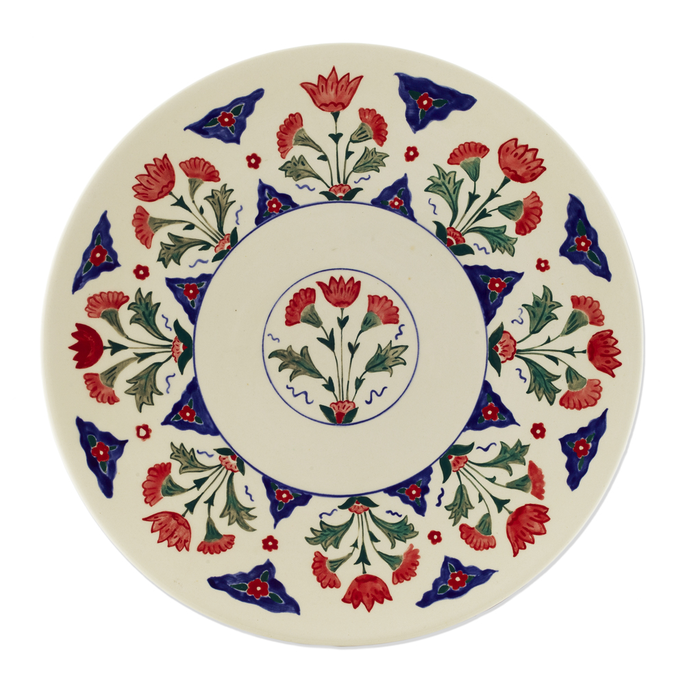
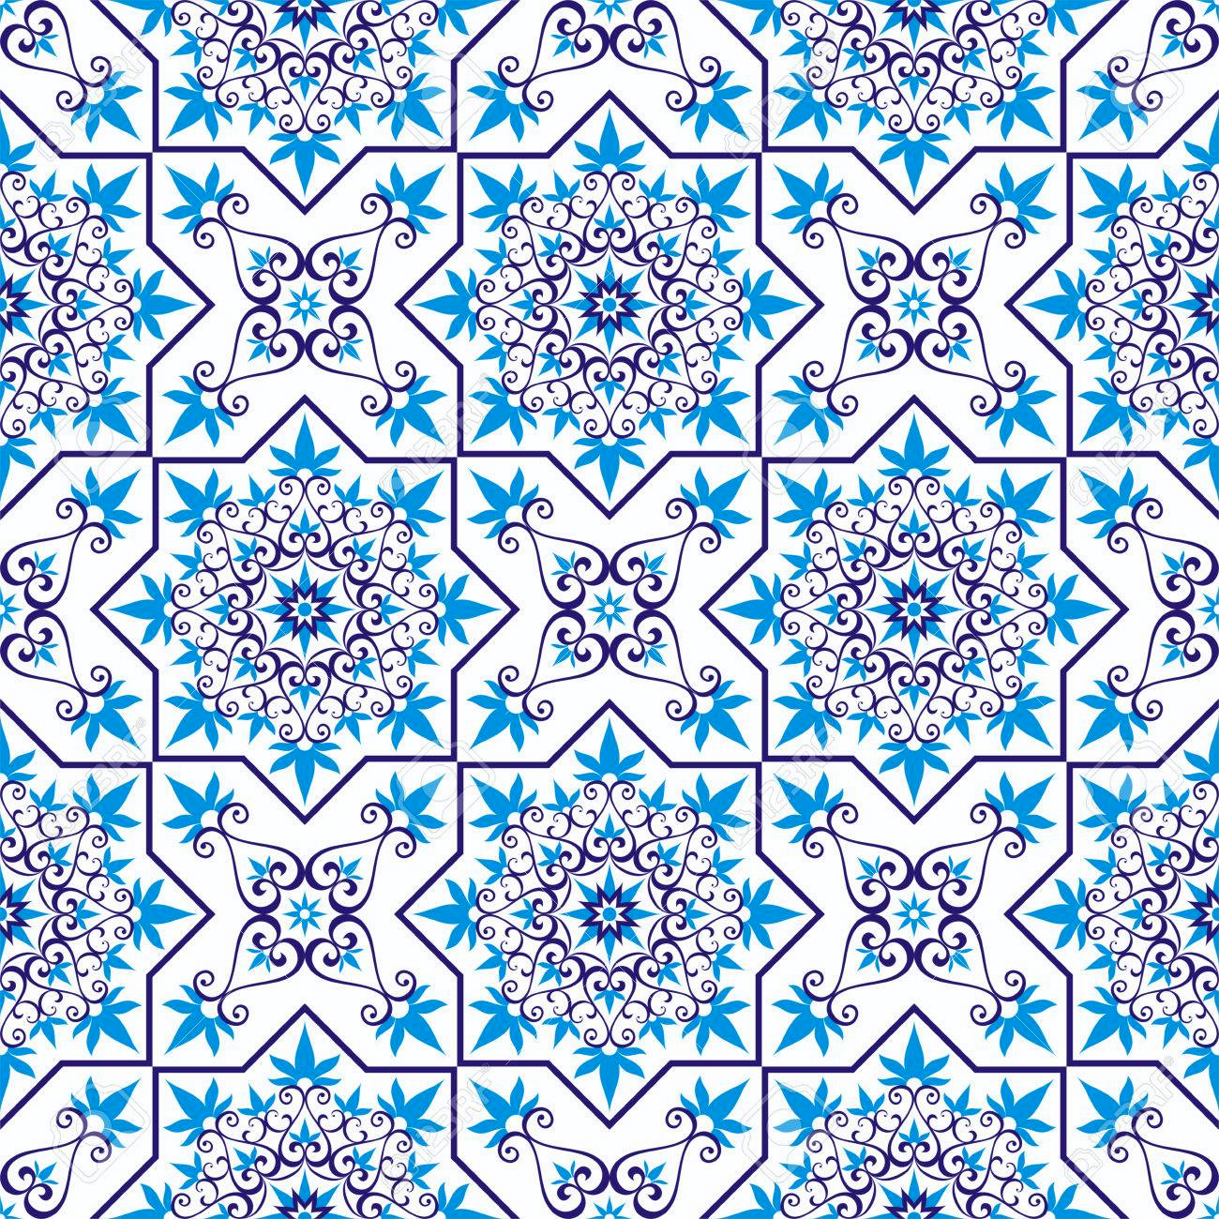

Announcements/Reminders:
- Get a Late Work Contract from me if you won’t be done with your still life today. WITH Late Work Contract: Due March 8th

Today’s Objective(s):
- Finish Still Life - TURN IN TODAY!!
  - Turn in Green “Chosen Still Life” worksheet
  - Turn in Pink “Symbolism: Still Life” Task Sheet!
  - Get Late Work Contract if you haven’t finished it.
- Design Check & Task Sheet - You HAVE to check off design with me before starting your sketchbook cover.
- Start Sketchbook Covers

Homework:
- CRITIQUE FOR STILL LIFE NEXT CLASS!!! BRING YOUR DRAWING WHETHER IT IS DONE OR NOT!!

