Date: February 14 & 18, 2020
In your journal record the following:
DRAWING ENTRY #9:
Reflective Writing: Look at the ink landscape below. What score would you give it according to the criteria listed on your task sheet.
Announcements/Reminders:
- Ink Landscapes due NEXT TIME!
Today’s Objective:
- Gesture drawing (football player)
- Watch clip
- Work on Ink Landscape
Homework: In your sketchbook do a 20-30 minute observational drawing of something you like to eat or drink (use the Look, Hold, Draw method).

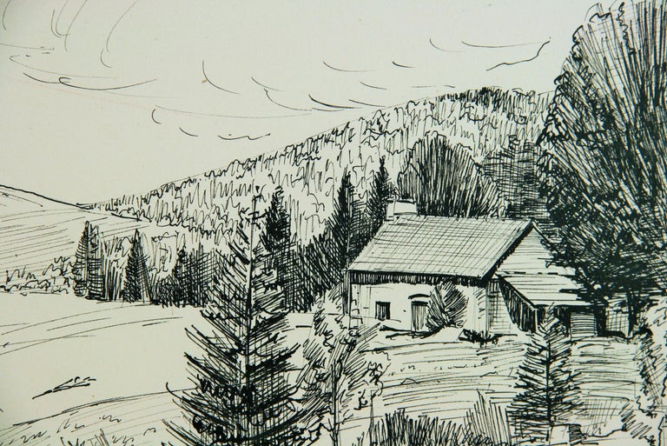
- Reference photo shows a variety of textures. (10 points possible)

- Ink textures are interesting, well done and show a variety of textures. (10 points possible)
- Texture lines show light and shadow areas. (10 points possible)

- Lighting (shadows, highlights, reflections and cast shadows) are consistent throughout the drawing. (10 points possible)
- Project shows time and effort and the workmanship is acceptable. (10 points possible)

