Date: February 12 & 13, 2020
In your journal record the following:
DRAWING ENTRY #8:
Reflective Writing: Look at the 4 ink landscape drawings below. Which do you like the best? Why?
Announcements/Reminders:
- Journal check TODAY!
Today’s Objective:
- Gesture drawing (boy balancing)
- Review Ink Landscape (go over task sheet)
- Work on Ink Landscape
Homework: In your sketchbook do a 20-30 minute observational drawing of something interesting in your room (use the Look, Hold, Draw method).

- 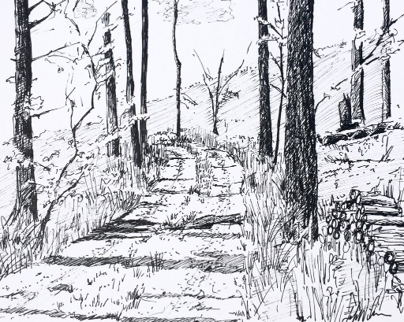 2. 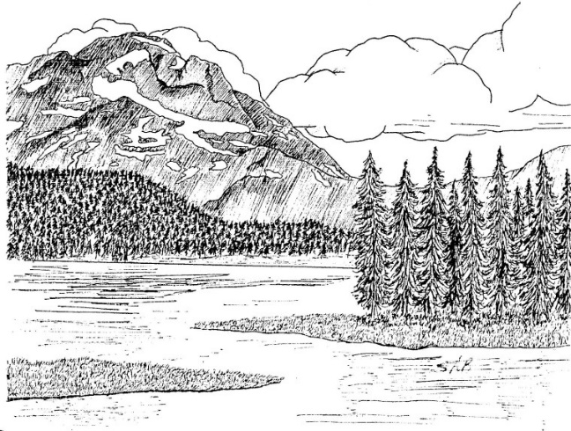

3.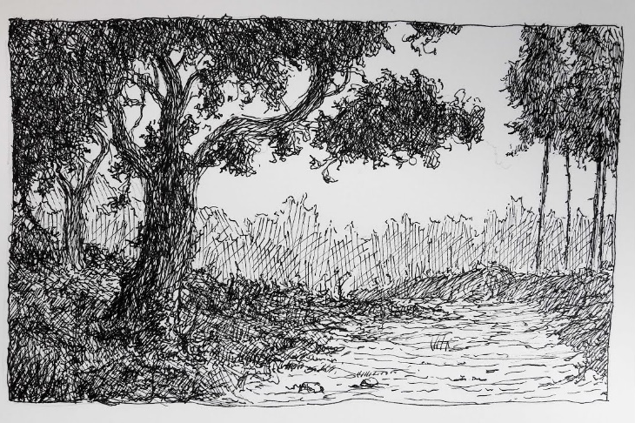 4. 