Date: May 20, 2021
Record the following in your journal:
DRAWING ENTRY #38:
Reflective Writing: How would you finish this sentence: The great thing about colored pencils is ___________________________.
Announcements/Reminders:
- Final journal check TODAY!
- TODAY is the last day to turn in late work for this term!
- Seniors need to turn in their illustration TODAY!
- Juniors and Sophomores can turn in their illustrations NEXT TIME!
Today’s Objectives:

- Review
- Work on Illustration project (seniors get checked off before you leave today).
Homework: Check your grade – let me know ASAP if there is a mistake.

1.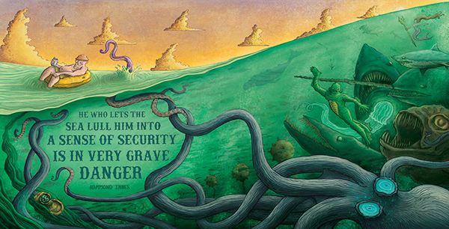
2.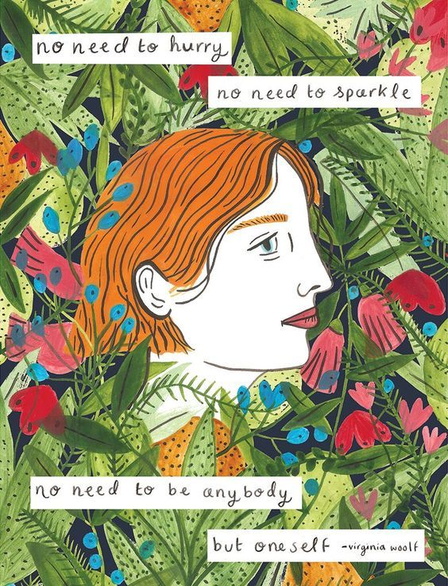3. 