Date: May 19, 2021
Record the following in your journal:
DRAWING ENTRY #36:
Reflective Writing: Last time we talked about 2 mistakes that are often made when blending colored pencils with mineral spirits. See if you can remember and write down at least one.
Announcements/Reminders:
- Final journal check TODAY!
- NEXT TIME is the last day to turn in late work for this term!
- Seniors need to turn in their illustration NEXT TIME!
Today’s Objectives:

- Pass out task sheets and go over criteria
- Work on Illustration project
Homework: Get any late work finished and ready to turn in.

1.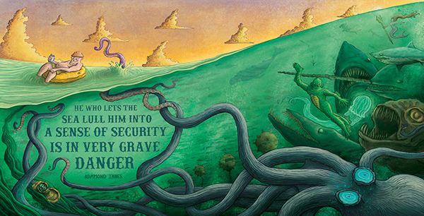
2.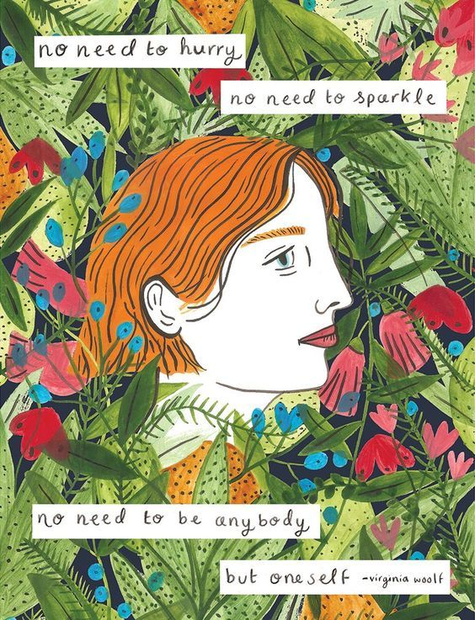3. 