Date: May 17, 2021
Record the following in your journal:
DRAWING ENTRY #35:
Reflective Writing: Look at the illustrations below: which do you think is the most effective illustration? WHY?
Announcements/Reminders:
- Turn in Fruit/Veg drawing (blending with mineral spirits) TODAY !
- Final journal check NEXT TIME!
- FRIDAY is the last day to turn in late work!
Today’s Objectives:

- Watch clip
- Work on Illustration project
Homework: Continue drawing in your sketchbook.

1.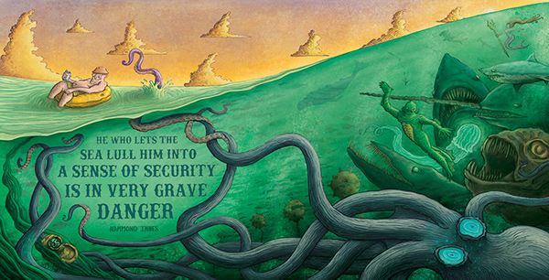
2.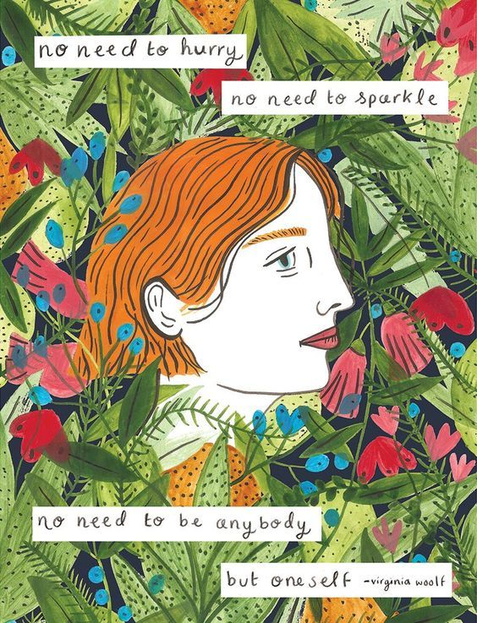3. 