Date: May 1 & 2, 2019
In your journal record the following:
DRAWING ENTRY #33:
ART THINK: In your opinion, what makes a good drawing?
Announcements/Reminders:
- Check off your landscape reference photo if you didn’t get it checked last time.
Today’s Objective:
- Gesture drawing (bird)
- Review
- Work on ink landscape drawings
Homework: Work in your visual journal.

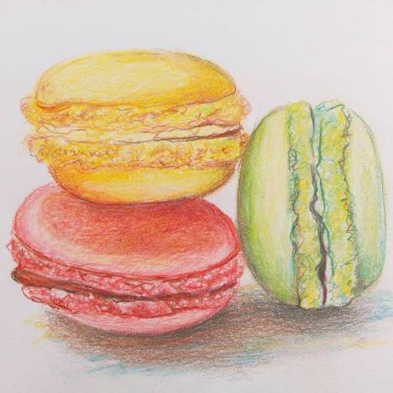

- 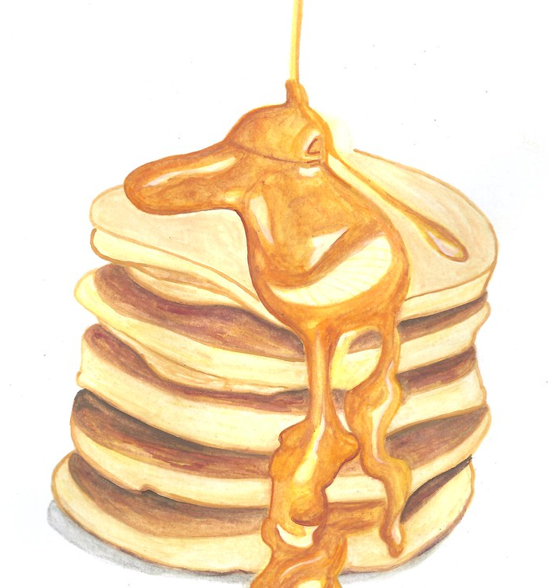 2.