Date: April 29 & 30, 2019
In your journal record the following:
DRAWING ENTRY #32:
ART THINK: REVIEW: What is the difference between a pattern and texture (according to the video clip we watched)?
Announcements/Reminders:
- Homework check TODAY (landscape reference photo)!
Today’s Objective:
- Gesture drawing (cat 2)
- Talk about starting landscape ink drawings
- Finish trees (if you didn’t last time)
- LIGHTLY drawing landscape composition (and boarder) or you can LIGHTLY trace IF it is your own photo.
- Begin inking in texture (if you have time)
Homework: Work in your visual journal.

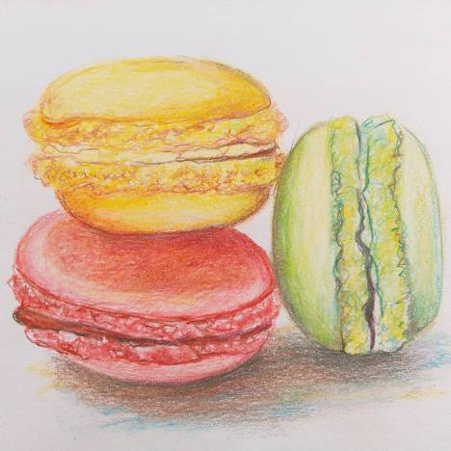

- 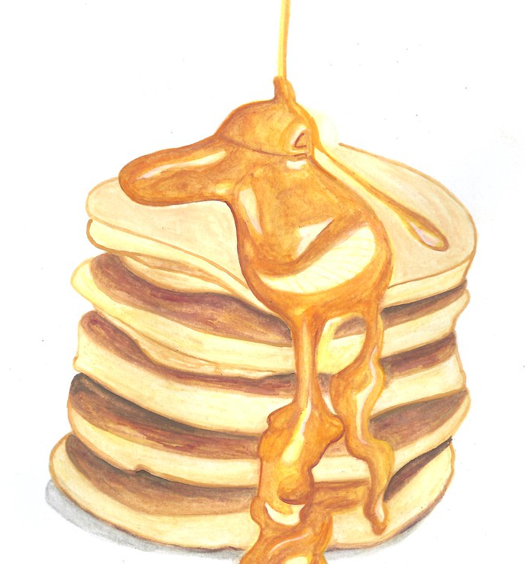 2.