Date: April 30 & May 3, 2021
Record the following in your journal:
DRAWING ENTRY #31:
Reflective Writing: Look at the artworks below. What do they all have in common?
Announcements/Reminders:
- Sunset Silhouette drawing due TODAY!
- Concurrent Enrollment Art Show entries due May 5th.
Today’s Objectives:

- Intro Colored Pencils
- Finish Sunset Silhouette drawing with pastels and turn in
- Do layer and burnish practice.

Homework: Continue drawing in your sketchbook.

- 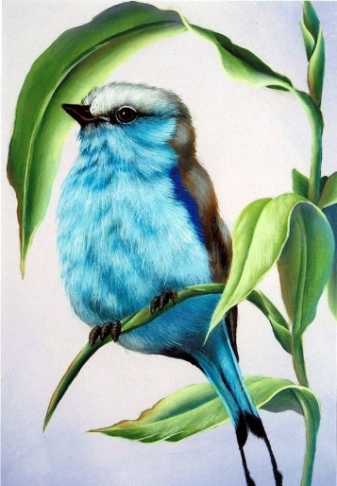 2. 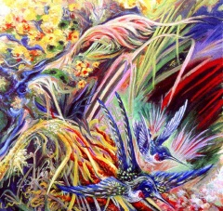 3.
4. 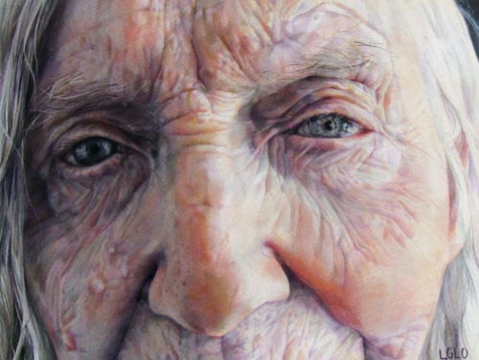 5.

