Date: April 25 & 26, 2019
In your journal record the following:
DRAWING ENTRY #31:
ART THINK: What is your favorite drawing medium and WHY?
Announcements/Reminders:
- CHANGE: Homework check NEXT TIME (landscape reference photo)!
Today’s Objective:
- Watch clip
- Finish texture cylinder and turn in (if you didn’t last time)
- Draw 3 different types of trees in your visual journal. (Make sure they look 3D by adding the shadows and leaving high lights!)
Homework: Take or find a landscape reference photo (to recreate in pen and ink). Bring an 8x10 grayscale print next time.

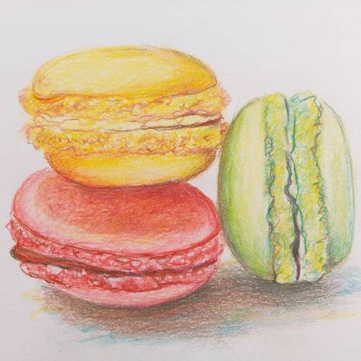

- 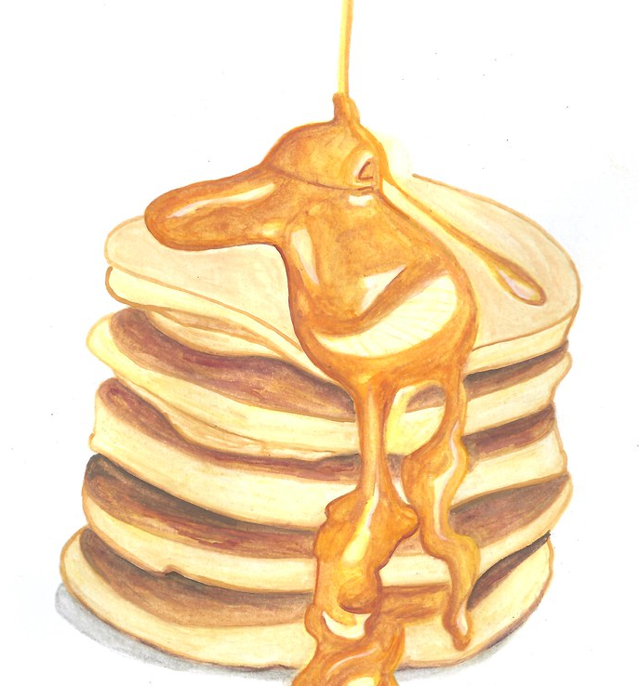 2.