Date: April 23 & 24, 2019
In your journal record the following:
DRAWING ENTRY #30:
ART THINK: How did your food drawing turn out? What worked well? What would you change if you did it again?
Announcements/Reminders:
- Homework check next time (landscape reference photo)
Today’s Objective:
- Gesture Drawing (cat)
- Review creating values with pen and ink
- Watch clip
- Draw a texture cylinder
Homework: Take or find a landscape reference photo (to recreate in pen and ink). Bring an 8x10 grayscale print next time.

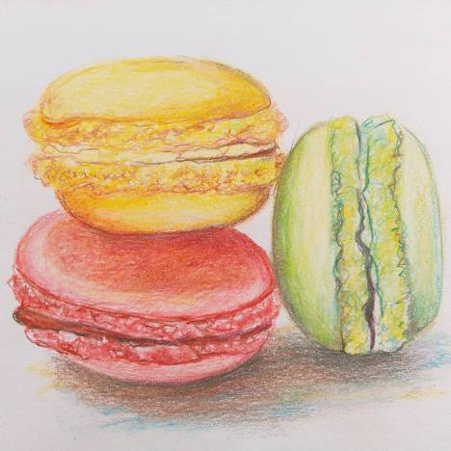

- 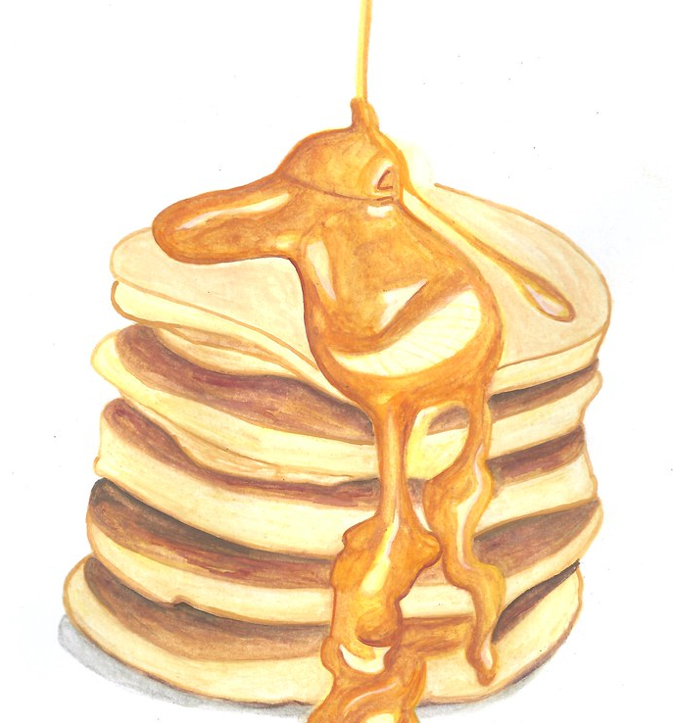 2.