Date: April 19 & 22, 2019
In your journal record the following:
DRAWING ENTRY #29:
ART THINK: Look at the drawing below. What would you change or add to improve the drawing?
Announcements/Reminders:
- Food drawing is due TODAY – make sure to get a late contract if you can’t finish today.
Today’s Objective:
- Intro to ink (video clip)
- Finishing Food drawing and turn in
- Do 4 pen & ink spheres.
Homework: Work in visual journal.

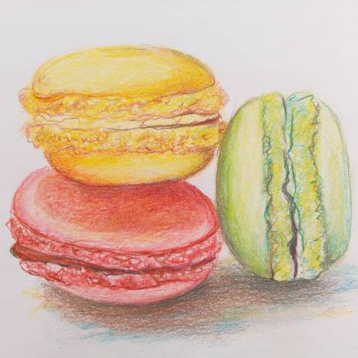

- 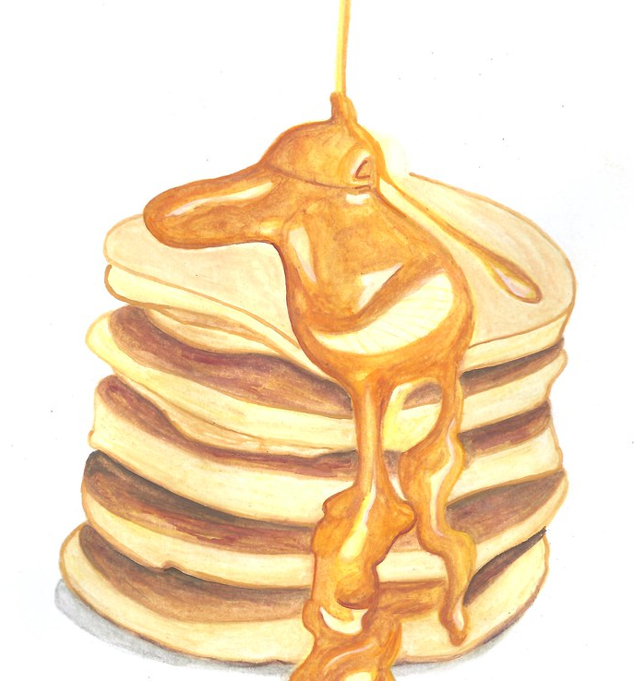 2.