Date: April 17 & 18, 2019
In your journal record the following:
DRAWING ENTRY #28:
ART THINK: Look at the colored pencil drawings below. Which drawing do you think is the best (most effective) and WHY?
Announcements/Reminders:
- Get your Visual Journal checked TODAY if you didn’t last time!
- CHANGE: Food drawing is due NEXT TIME! (Today is the last day we will work on it in class.)
Today’s Objective:
- Warm up gesture (horse 2)
- Finishing Food drawing
Homework: Finish Food drawing if you do not finish in class!

- 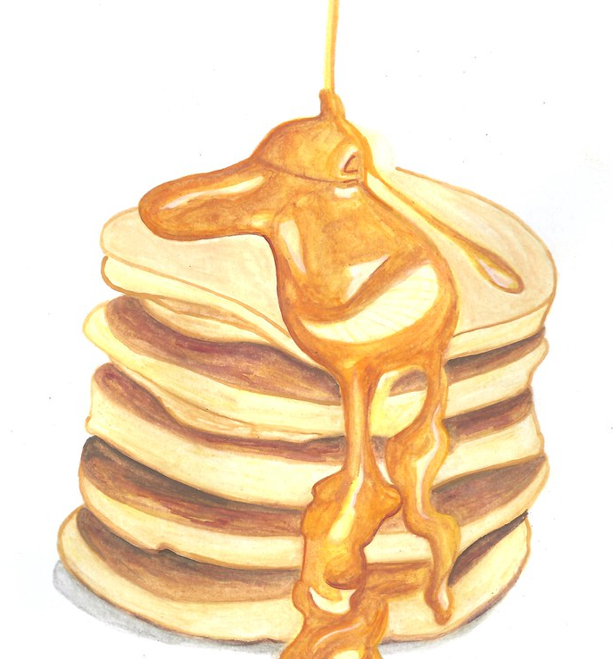 2.