Date: March 19 & 22 2021
Record the following in your journal:
DRAWING ENTRY #19:
Reflective Writing: Look at the 3 drawings below. Which do you think is the most effective drawing and WHY?
Announcements/Reminders:
- NEXT TIME is the last day to turn in late work for this term!
- Animal Grid drawings are due NEXT TIME!
- Sketchbook Check #2 TODAY! (Sketchbook prompts #1-5 + 1 hour of drawing on your own)
Today’s Objectives:

- Gesture warm up
- Finishing Grid Animal drawing
- Work in sketchbook (if you get finished)

Homework: Finish Grid Animal drawing

- 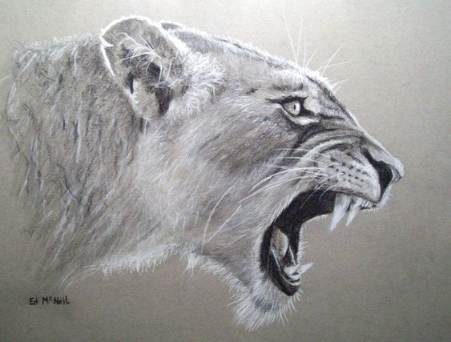 2. 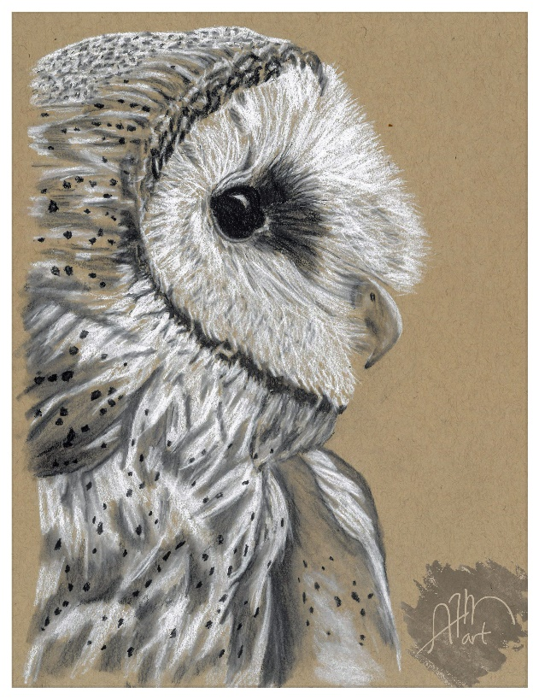
3. 