Date: March 14th & 15th, 2017
In your journal record the following:
Drawing #18:
ART THINK: Look at the Little Red Riding Hood Images and Answer the questions.
Announcements/Reminders:
- Portraits are due TODAY!!!
- Journal check TODAY!
Today’s Objective:
- Introduce Poetry Project
- Turn in Portraits
- Create an illustration of a story book character (your own interpretation).
Homework: Finish your story book character drawing if you don’t finish in class.

A.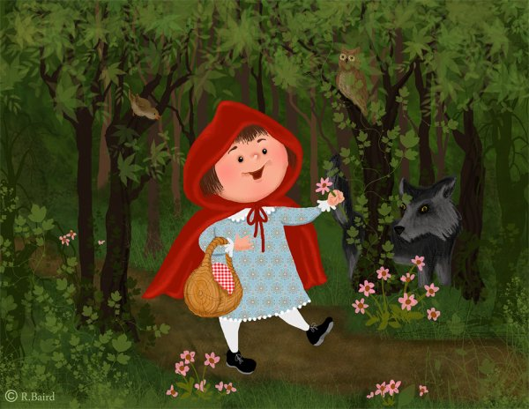 B.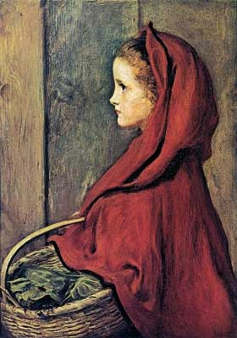 C.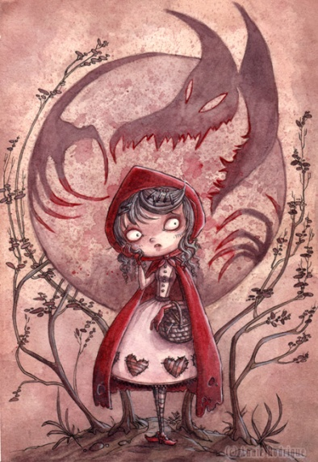
- Which illustration is more true to the text and why?
- Which illustration does better at going beyond the text in creative ways and why?

