Date: March 6 & 7, 2019
In your journal record the following:
DRAWING ENTRY #16:
ART THINK: See if you can match the self-portrait to the artist below:
Announcements/Reminders:
- Check on Visual Journal and Warm Up Gesture sketch book check is March 12 &13!
Today’s Objective:
- Warm up gesture (volley ball player)
- Review
- Work on Grid Portrait
Homework: Work in your visual journal!

See if you can match the artist to the self portrait:
1. Rembrandt 2. Vincent Van Gogh 3. Andy Warhol 4. Frieda Kahlo 5. Albrecht Durer 6. Pablo Picasso.
A.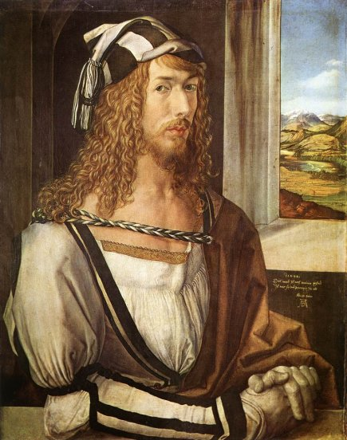B.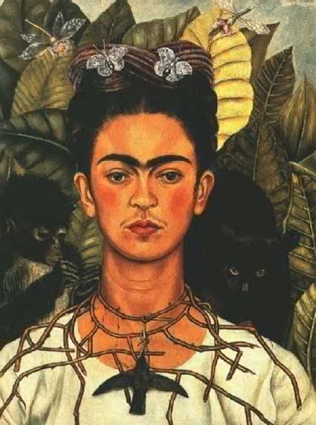C. 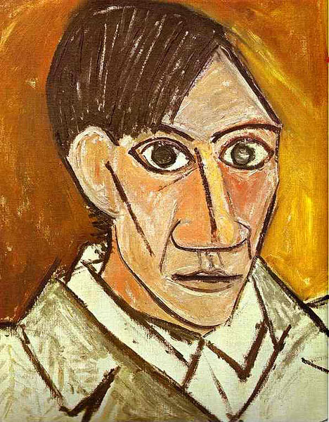

D.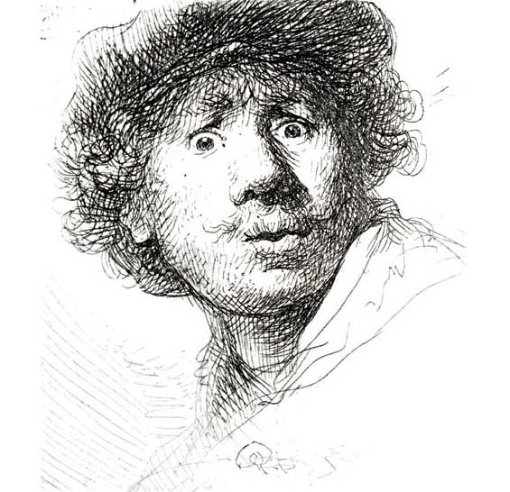E. 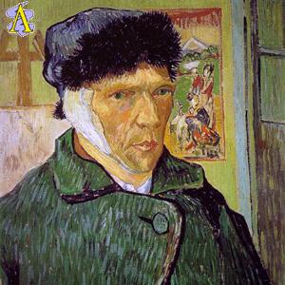F. 