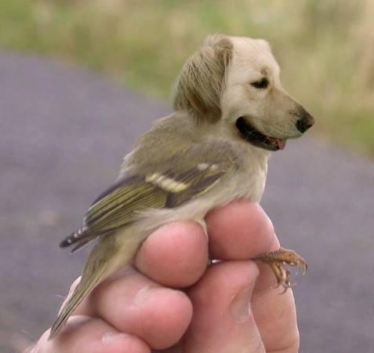 NAME: _________________________________
Class: _______
“CREATE YOUR OWN CREATURE” DRAWING TASK SHEET
YOUR TASK: Combine the characteristics of at least two different animals to create your own unique creature. Draw a picture of this creature using pencils and colored pencils.
STEPS TO FOLLOW:
- Look at some examples of creature combinations.
- Make some sketches of your idea.
- Choose your best idea and draw your design lightly on to a large paper. Draw big so you can add lots of details.
- Continue working into a finished drawing, using pencil and colored pencil (USE ALL THE SKILLS YOU HAVE LEARNED IN CLASS!)
- Turn in with this score sheet to be graded.
CRITERIA AND SCORE SHEET
CRITERIA | SELF SCORE | TEACHER’S  SCORE
- Idea is creative and original and uses characteristics from at least 2 different animals. (10 points possible)
- Uses skills learned in class (layer & burnish, shading, etc). (10 points possible)
- Shows a variety of realistic textures (furry, scaly, bumpy, slimy, shiny, smooth, etc. (10 points possible)
- Creature has many realistic details. (10 points possible)
- Project shows time and effort. (10 points possible)
(TOTAL)
TOTAL POINTS (50 possible)

