[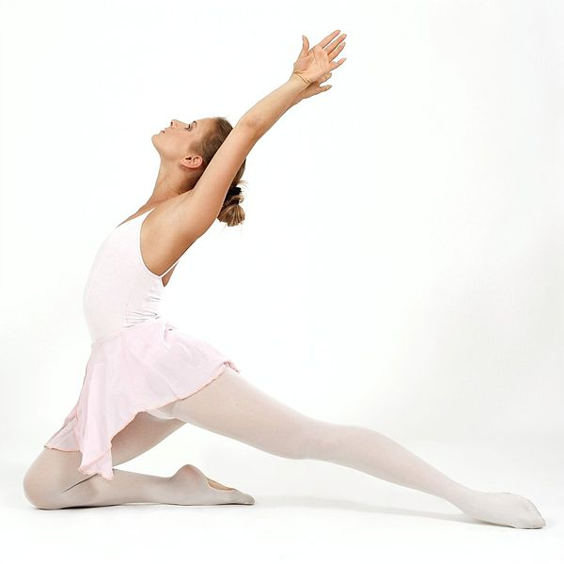](http://upload.wikimedia.org/wikipedia/commons/f/f6/Ballet-dancer_01.jpg)