Sept. 24, 2018
Art Foundations
Journal Entry #9
ART THINK: Which of the art works below do you like, or connect to the most and WHY?
Now record on your Assignment/Homework Log the following:
Assignment/Homework | Due Date
Journal check | TODAY
Rain drips and shading on simple shapes | Sept. 26th NEXT TIME
HW: #6 sketch book prompt | NEXT TIME

Discuss objectives for the day or what we will try to get done:
- Discuss Art Think
- Review and talk about value scale
- Finish rain drips and simple shapes
- Create value scale (white on black)

Which of the following artworks do you connect with the most and WHY:
1. 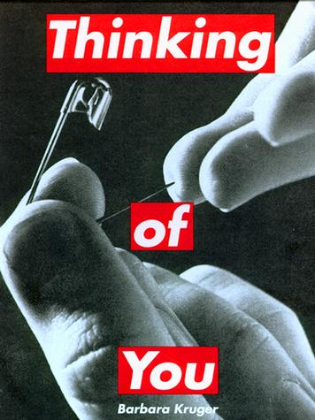 2. 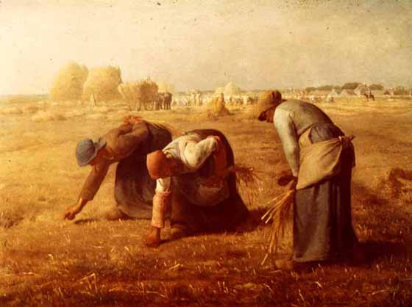3.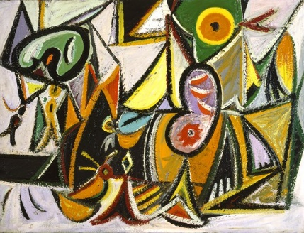 4. 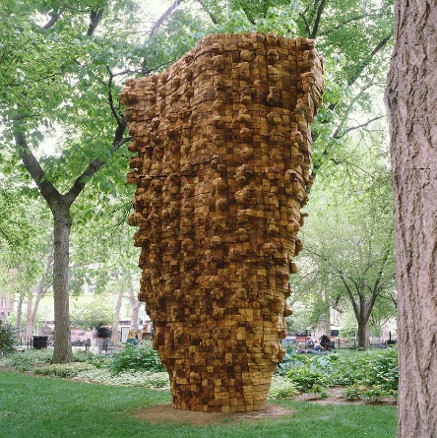5.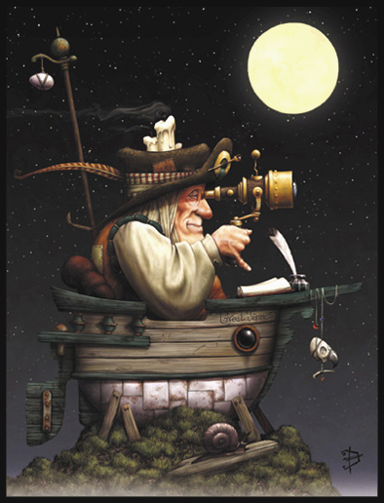6.

