Sept 20, 2019
Art Foundations
Journal Entry #9
- ART THINK: Which of the art works below do you like, or connect to the most and WHY?

ANNOUNCEMENTS/REMINDERS:
- Journal check TODAY!
OBJECTIVES:
- Review (go over task sheets)
- Work on doodle portraits

Which of the following artworks do you connect with the most and WHY:
1. 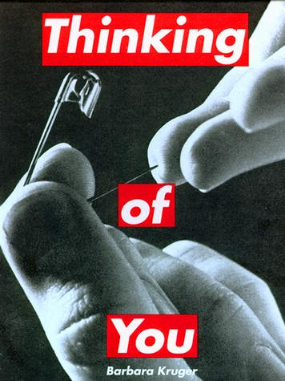 2. 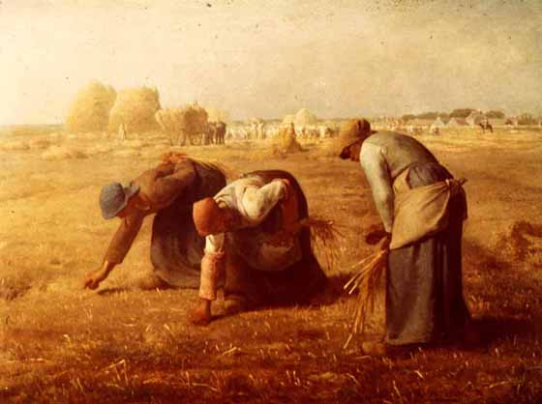3.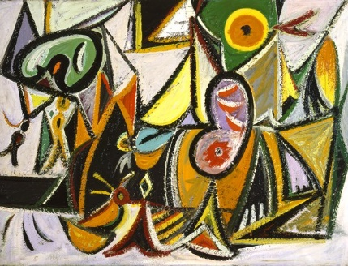 4. 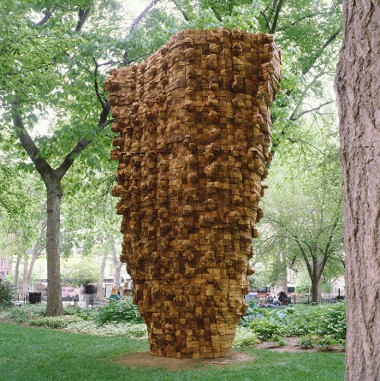5.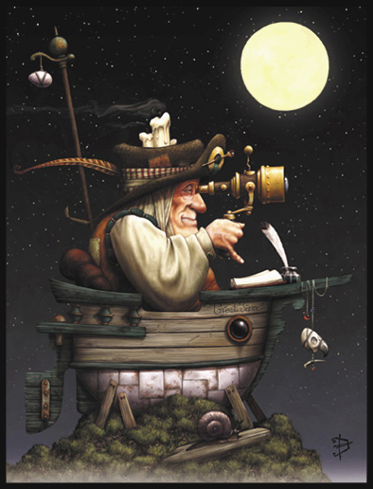6.