Sept. 20, 2018
Art Foundations
Journal Entry #8
ART THINK: See if you can identify the parts of the lighting on the sphere below:
Now record on your Assignment/Homework Log the following:
Assignment/Homework | Due Date
HW: Get sketch book ready to turn in. | TODAY
Sketch Book Cover design (with 5 prompts) | TODAY
Journal check | Next Time

Discuss objectives for the day or what we will try to get done:
- Discuss Art Think
- Turn in sketch book
- Watch video clip (Draw a Water Drop)
- Draw 4 or 5 rain drips on toned paper

Can you identify the parts of the modeling on this sphere?

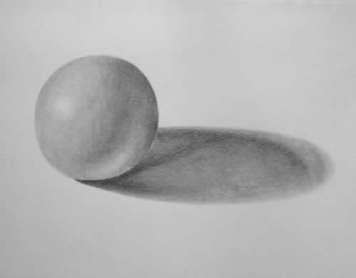
4.
2.
1.
3.

