Sept. 14, 2020
Art Foundations
Journal Entry #7
ART THINK: Which of the artworks below do you connect with the most and WHY?
ANNOUNCEMENTS/REMINDERS:
- Check off your Sketch Book Cover TODAY if you didn’t last time!
- Homework check (photocopy of a face) TODAY
- Extra credit album cover contest DUE Sept 17th
OBJECTIVES:
- Intro Gesture drawing
- Review
- Work on Doodle Portrait

Which of the following artworks do you connect with the most and WHY:
1. 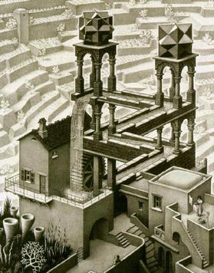 2. 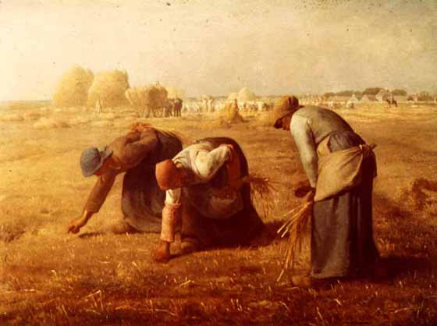3. 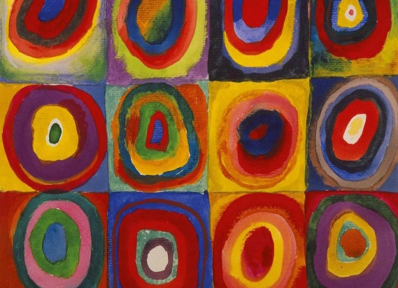 4. 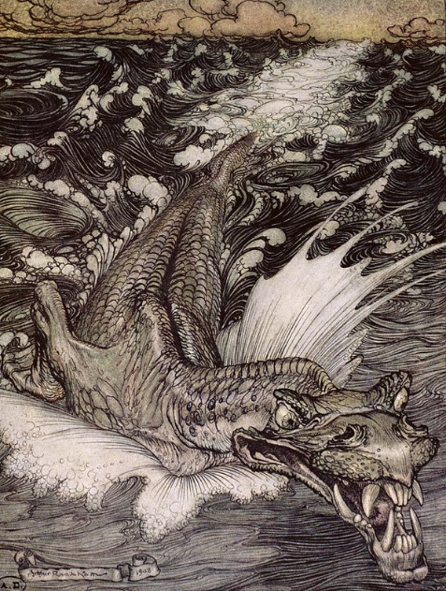 5.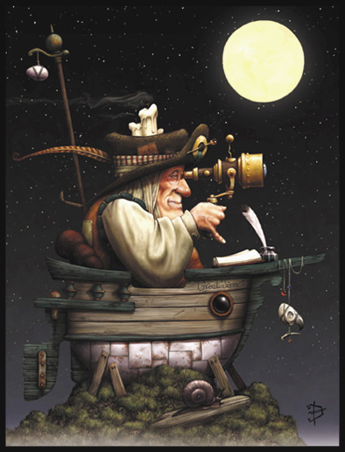6.