Sept. 13, 2021
Art Foundations
Journal Entry #7
ART THINK: Review: What is the most important rule of sketchbooks?
ANNOUNCEMENTS/REMINDERS:
- Doodle portrait due Sept 17th
OBJECTIVES:
- Do sketch book prompt #3: Grab an object and turn it into a character (spend at least 15 minutes).
- Review
- Work on Doodle Portrait

Which of the following artworks do you connect with the most and WHY:
1. 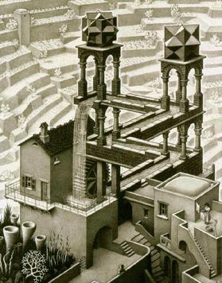 2. 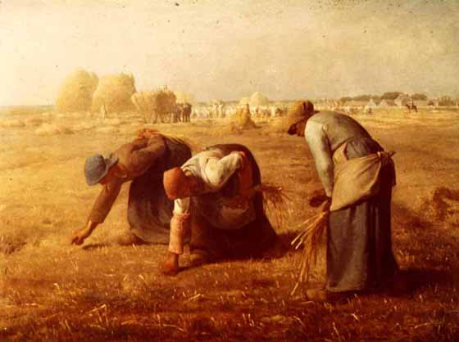3. 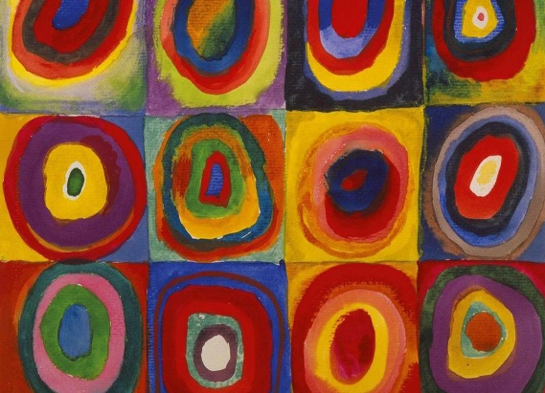 4. 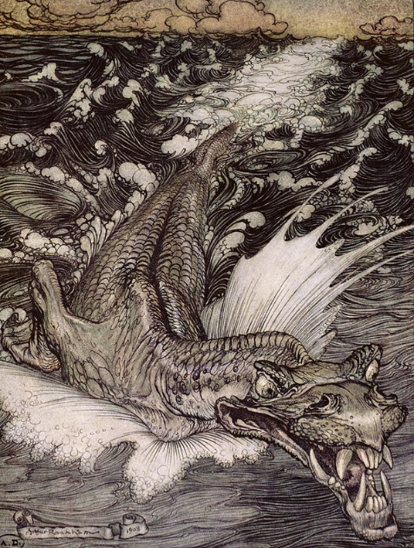 5.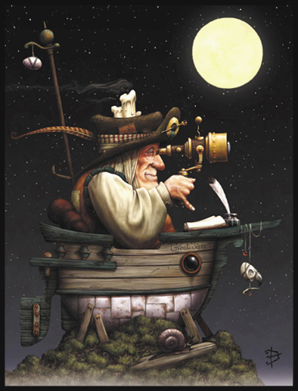6.