Sept. 14, 2018
Art Foundations
Journal Entry #6
ART THINK: Look at the art work below and answer the questions:
Now record on your Assignment/Homework Log the following:
Assignment/Homework | Due Date
HW: Sketch book assignment #5 (use a prompt) | Tues Sept 18
CHANGE: Sketch Book Cover design (and 5 prompts) | Thurs Sept 20

Discuss objectives for the day or what we will try to get done:
- Discuss Art Think
- Review Sketch Book Cover criteria
- Finishing sketch book cover

Look at this artwork and answer the following questions:
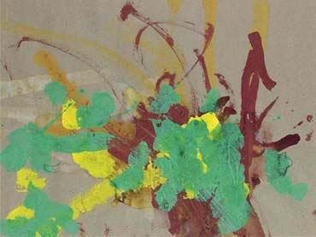
- Do you consider this to be art? Why or why not?
- What if I told you it sold for over $25,000.00, would that change your opinion? Why or why not?
- What if I told you Picasso owned an artwork by this artist, would that change your opinion? Why or why not?

