Sept. 8, 2020
Art Foundations
Journal Entry #5
ART THINK: Look at the artwork below and answer the questions:
ANNOUNCEMENTS/REMINDERS:
- Sketch Book Cover DUE NEXT TIME!
- HOME WORK: Bring a gray scale print of a face 8 x 10 if you forgot this time.
- Extra credit album cover contest (for Homecoming)
OBJECTIVES:
- Review Sketch Book Cover assignment
- Work on Sketch Book Cover
- Work in Sketch Book (if you get finished)

Look at this artwork and answer the following questions:
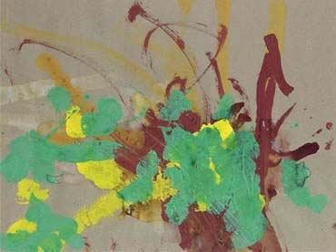
- Do you consider this to be art? Why or why not?
- What if I told you it sold for over $25,000.00, would that change your opinion? Why or why not?
- What if I told you Picasso owned an artwork by this artist, would that change your opinion? Why or why not?

