December 15, 2021
Art Foundations
Journal Entry #37
- ART THINK: See if you can guess what the art works below all have in common:
ANNOUNCEMENTS/REMINDERS:
- Check off your origami TODAY!
- Words to Live By project is due TODAY! (Turn in to the “In” basket with a task sheet.)
OBJECTIVES:
- Watch clip
- Finish “Words to Live By” project & turn in
- Work on layer and burnish practice

- 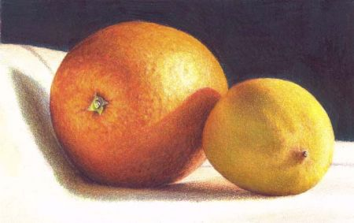
- 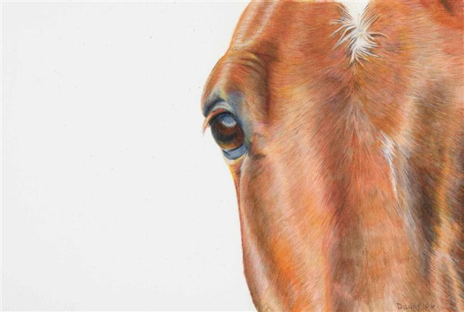
3. 