December 9, 2021
Art Foundations
Journal Entry #35
- ART THINK: See if you recognize the famous Children’s book illustrations below:
ANNOUNCEMENTS/REMINDERS:
- Words to Live By project is due NEXT TIME!
- Sketchbook check is coming up. Keep drawing in your sketchbook!
OBJECTIVES:
- Talk about adding texture and value with ink and adding text.
- Finishing “Words to Live By” project
- Draw in sketch book (if you have time)

- 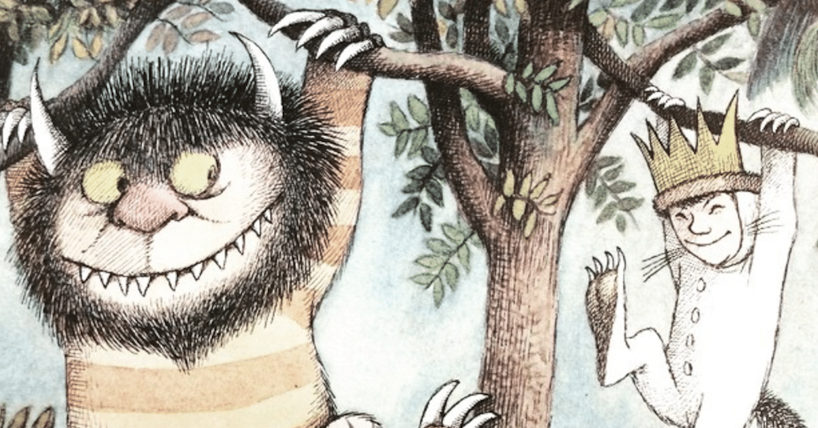 2. 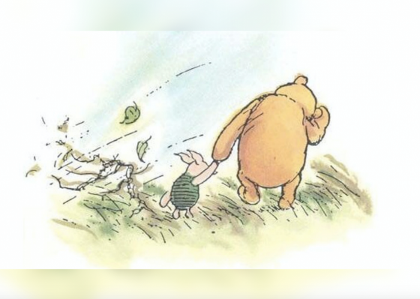
3. 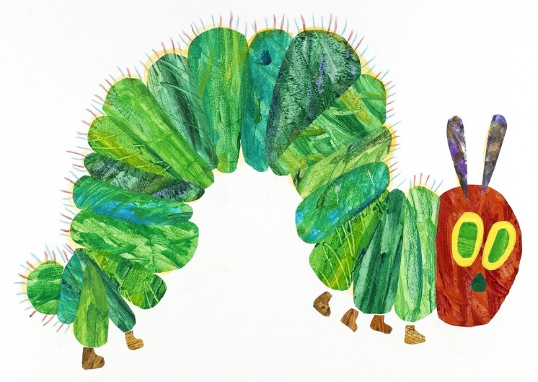 4.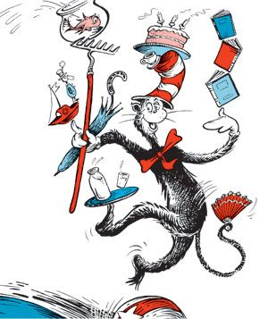

5. 