December 3, 2021
Art Foundations
Journal Entry #33
- ART THINK: Which one of the illustrations below do you think is the most successful and WHY?
ANNOUNCEMENTS/REMINDERS:
- Turn in your silhouette today if you didn’t last time!
OBJECTIVES:
- Review Words to Live By project
- Work on “Words to Live By” project

- 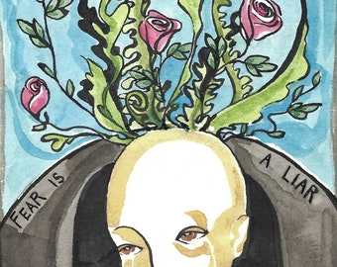 2. 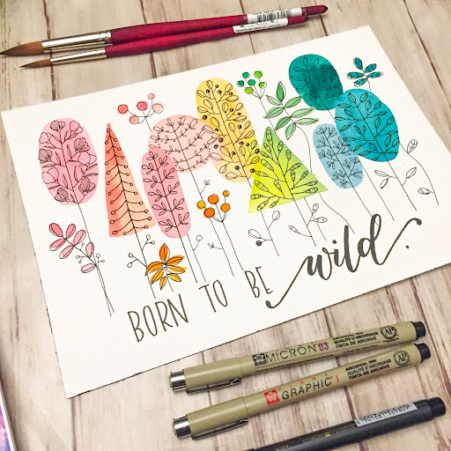
3. 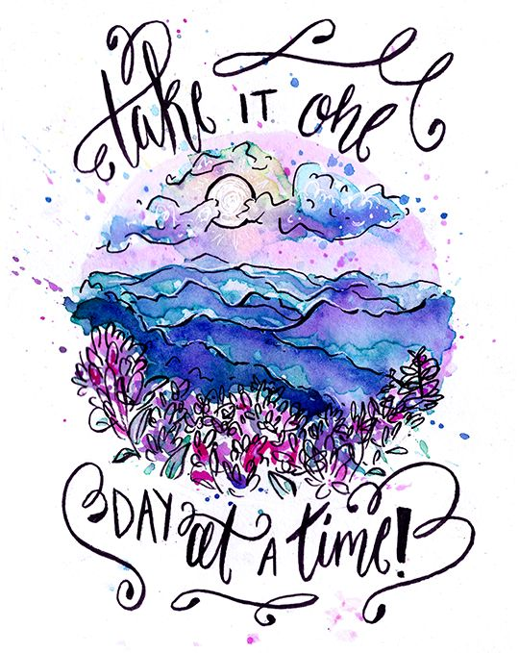 4. 