Nov 11, 2019
Art Foundations
Journal Entry #26
- ART THINK: Look at the art works below. Write down what you think they all have in common.
ANNOUNCEMENTS/REMINDERS:
- Art History Power Point Presentation are due NEXT TIME (must share them with me)! We will begin presenting them on Friday.
- Scratch boards due TODAY
OBJECTIVES:
- Sign up for a time to present.
- Intro to Colored Pencil techniques (watch clip)
- Finish and turn in Scratch Board project
- Do Layer and Burnish practice

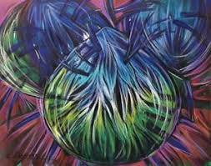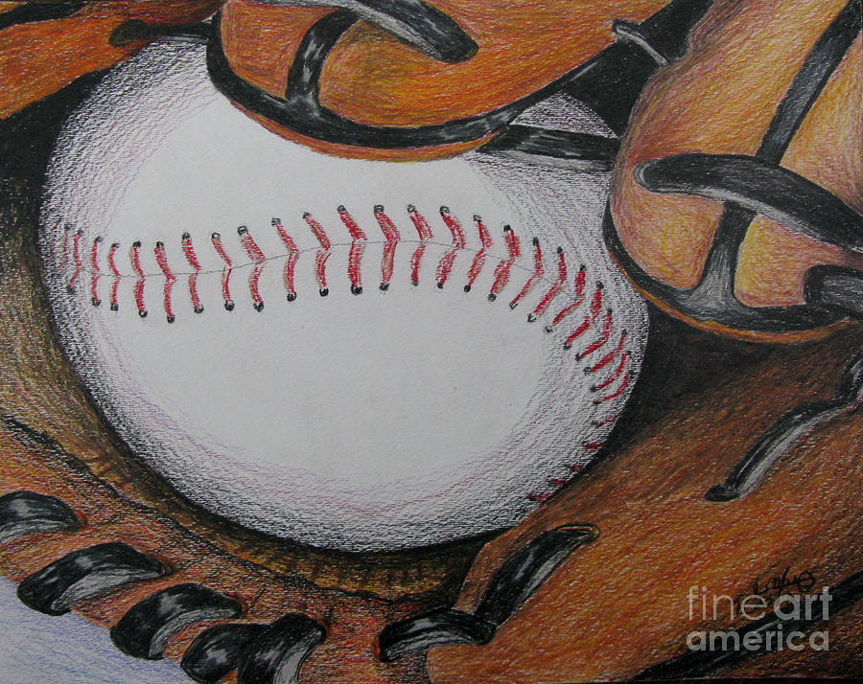
1.
2.
3.
4.

