Nov 7, 2019
Art Foundations
Journal Entry #25
- ART THINK: How will you make your Art History Power Point interesting and creative?
ANNOUNCEMENTS/REMINDERS:
- Make sure you continue to draw in your sketchbook!
OBJECTIVES:
- Finish Art History Project (Share with Ms. Shuler when you are done!)
- If you get finished work on your Scratch Board or in your sketchbook.

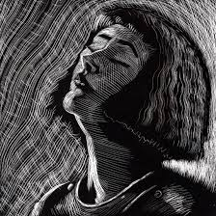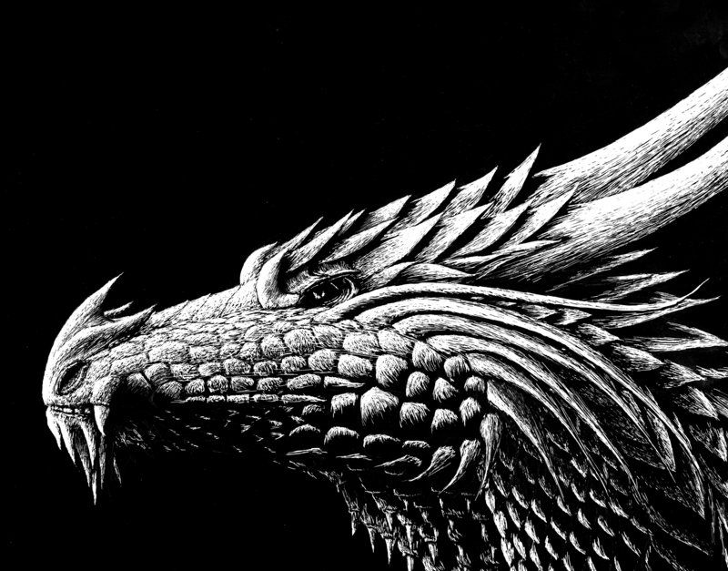
1.
2.

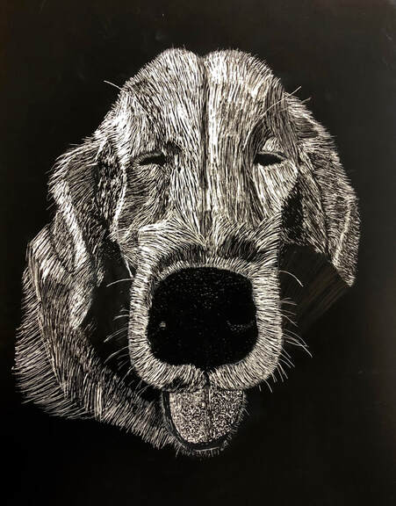
3.
4.

