Nov 5, 2019
Art Foundations
Journal Entry #24
- ART THINK: What is the most interesting thing you learned about your art movement from last time?
ANNOUNCEMENTS/REMINDERS:
- Make sure you continue to draw in your sketchbook!
OBJECTIVES:
- Work on Art History Project (Power Point)

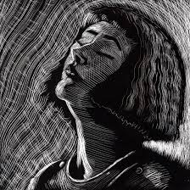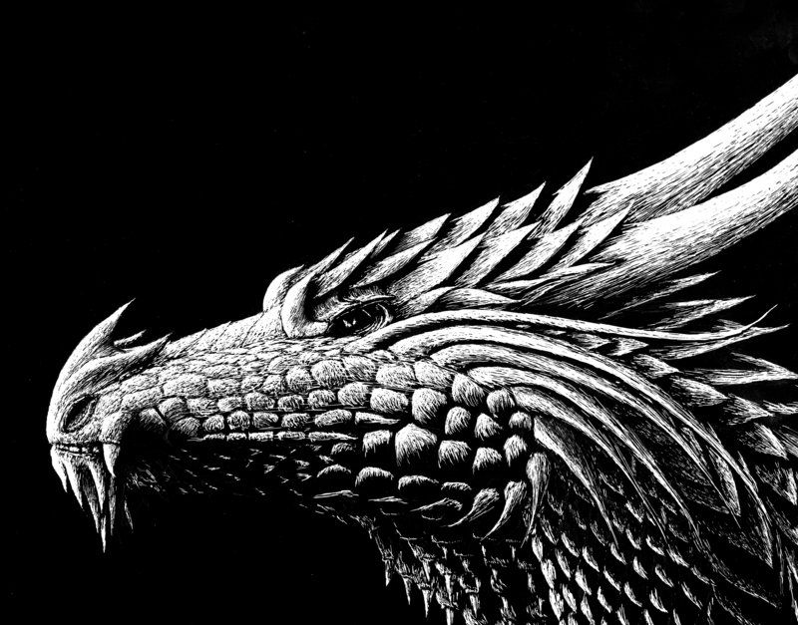
1.
2.

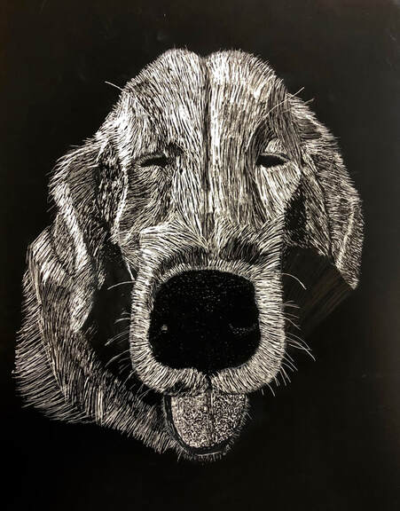
3.
4.

