Nov 1, 2019
Art Foundations
Journal Entry #23
- ART THINK: Do you know someone who is an artist? Who? What kind of art do they do?
ANNOUNCEMENTS/REMINDERS:
- Make sure you continue to draw in your sketchbook!
OBJECTIVES:
- Review Art History Project
- Research for Art History Project (complete yellow research paper)

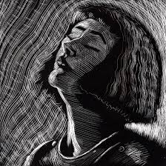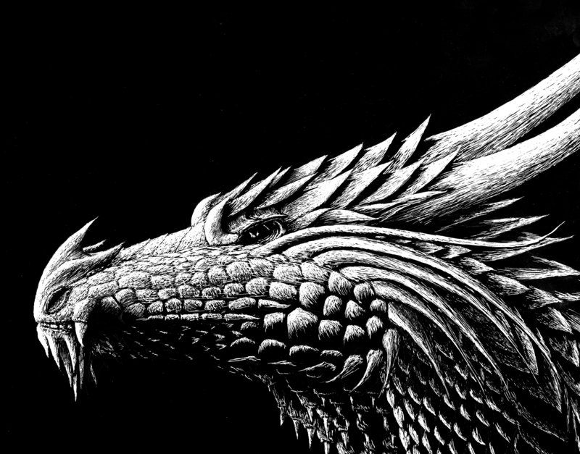
1.
2.

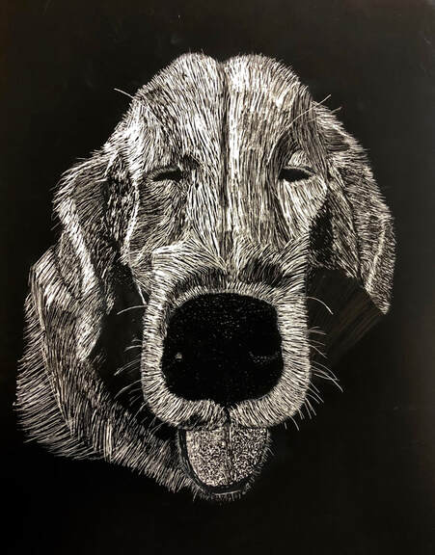
3.
4.

