October 30, 2019
Art Foundations
Journal Entry #22
- ART THINK: Where is the scariest, creepiest place you have ever been?
ANNOUNCEMENTS/REMINDERS:
- Scratch Board project is due Nov. 11th
- Make sure you continue to draw in your sketch book!
OBJECTIVES:
- Talk about next week
- Sign up for Art History project
- Review
- Work on scratch board project

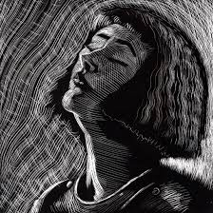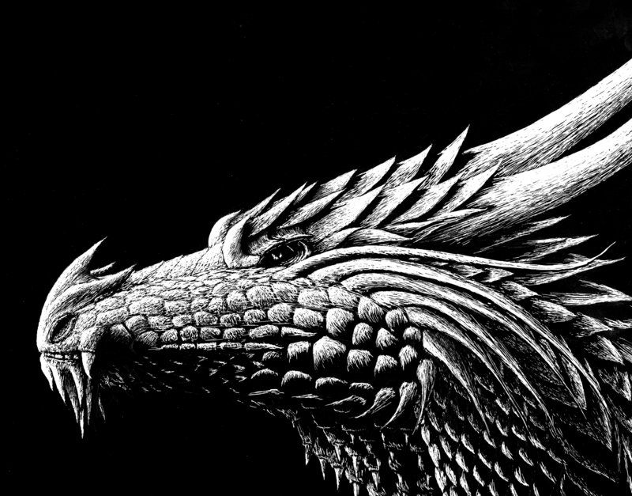
1.
2.

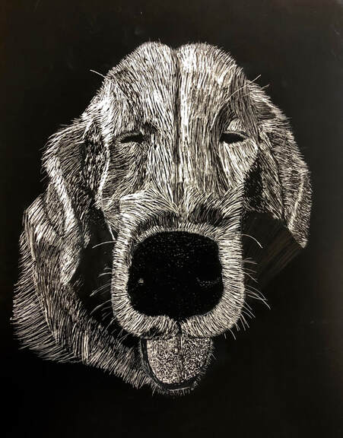
3.
4.

