October 28, 2019
Art Foundations
Journal Entry #21
- ART THINK: Look at the scratchboard drawings below and write down which one you like the best and WHY you like it.
ANNOUNCEMENTS/REMINDERS:
- None today
OBJECTIVES:
- Review steps for scratch board
- Finish practice scratch board
- Begin final scratch board project

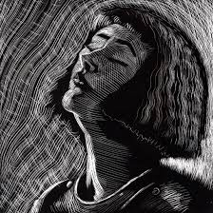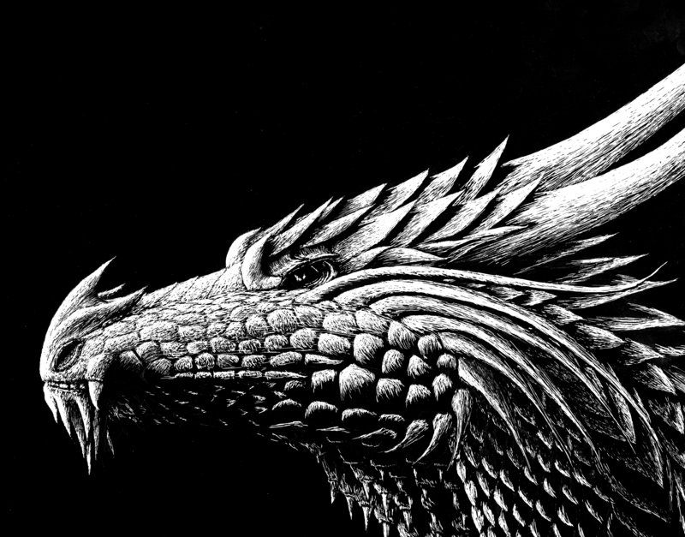
1.
2.

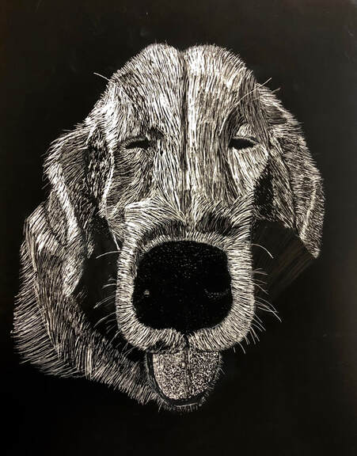
3.
4.

