October 22, 2019
Art Foundations
Journal Entry #19
- ART THINK: See if you can identify the parts of modeling on the sphere below:
ANNOUNCEMENTS/REMINDERS:
- HOMEWORK: Find or take a reference photo for scratchboard assignment.
OBJECTIVES:
- Talk about scratchboard project
- Finish white on black drawing
- Work in sketch book (if you get finished)

Can you identify the parts of the modeling on this sphere?

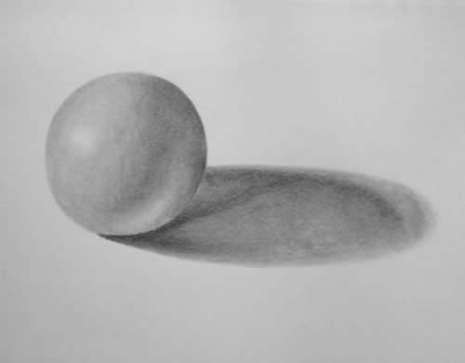
1.
4.
2.
3.

