October 14, 2020
Art Foundations
Journal Entry #18
- ART THINK: If you had to describe your “artistic style” to someone, what would you say?
ANNOUNCEMENTS/REMINDERS:
- Get your Sketchbook checked TODAY if you didn’t last time!
OBJECTIVES:
- Gesture warm up
- Watch clip
- Work on Scratch Board project

- 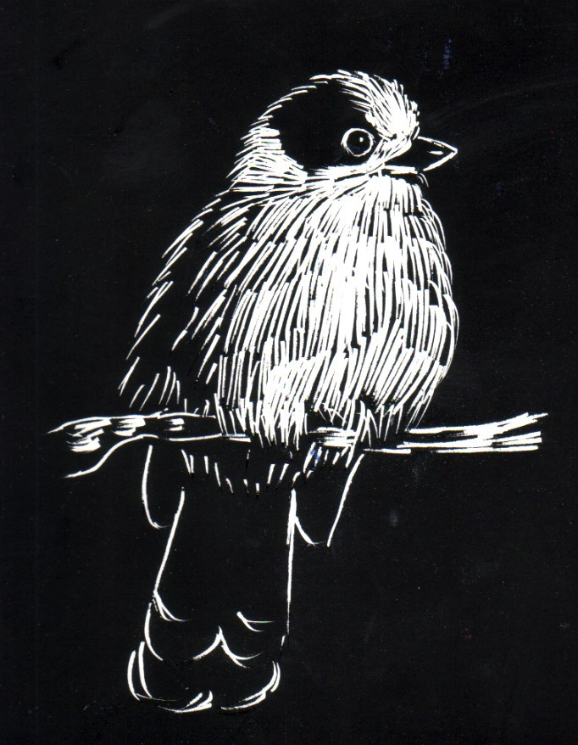 2. 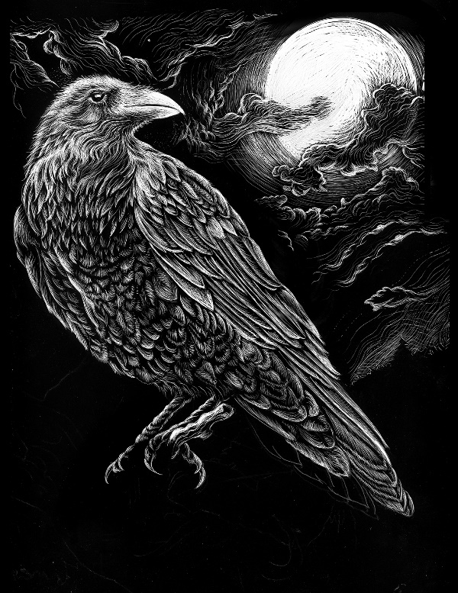
3. 