Date: Oct 13, 2017
In your journal record the following:
ART FOUNDATIONS ENTRY #17:
ART THINK: Look at the illustrations from the story Little Red Riding Hood below and answer the questions.
Announcements/Reminders:
- Sketch book check on Oct 23rd.
- October 25 is the last day to turn in late work or re-dos for this term.
Today’s Objective:
- Watch clip “Top 7 Mistakes in Colored Pencil”.
- Review.
- Work on illustration project.
Homework: Get caught up if you are behind.

A.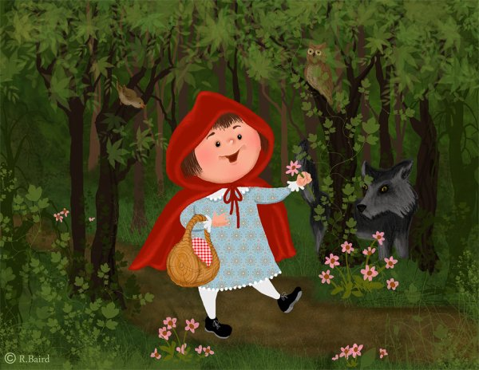 B.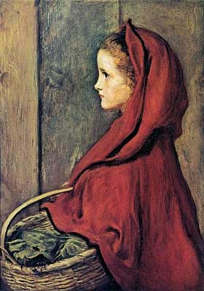 C.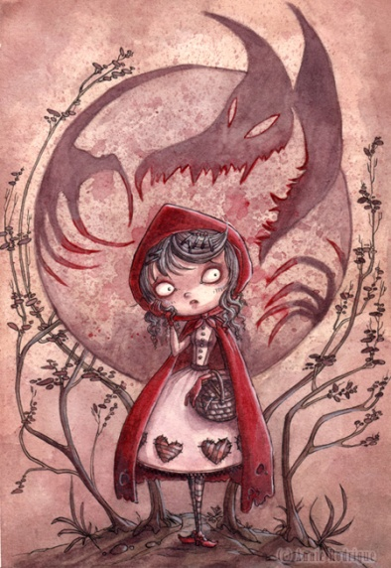
- Which illustration is more true to the story? Why?
- Which illustration does better at going beyond the text in creative ways? Why?
- Which illustration makes you want to read the story more and why?

