October 2, 2019
Art Foundations
Journal Entry #13
- ART THINK: Review: What is a reflected light and where is it found?

ANNOUNCEMENTS/REMINDERS:
- Your sketch book cover DUE TODAY
- HOME WORK: In your sketchbook, using the modeling guidelines discussed today, draw a pencil, pen or marker. (Draw for at least 20 min.) 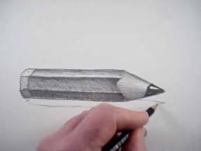
OBJECTIVES:
- Go over modeling guidelines.
- Check off your sketchbook cover if you need to
- Finish 4 simple shapes in your sketch book.
- Begin torn photo drawing

