Sept. 24, 2021
Art Foundations
Journal Entry #11
- ART THINK: Review: see if you can get the correct the correct term for each of the areas on the sphere below.
ANNOUNCEMENTS/REMINDERS:
- Journal check TODAY!
- Sketchbook check NEXT TIME!
OBJECTIVES:
- Go over “modeling guidelines”
- Intro to Torn Photo drawing
- Work on sketchbook or begin Torn Photo drawing

Can you identify the parts of the modeling on this sphere?

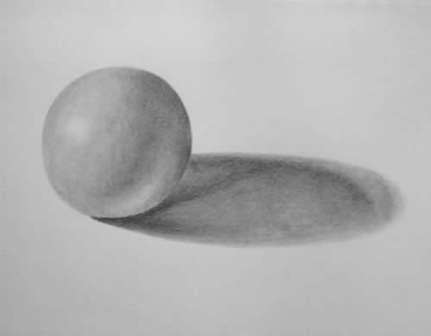
3.
4.
1.
2.

