Sept. 26, 2018
Art Foundations
Journal Entry #10
ART THINK: Which of the art works below do you like, or connect to the most and WHY?
Now record on your Assignment/Homework Log the following:
Assignment/Homework | Due Date
Journal check (forgot last time) | Sept 26th
Rain drips and shading on simple shapes | Sept. 26th
HW: #7 sketch book prompt | Sept. 28th

Discuss objectives for the day or what we will try to get done:
- Discuss Art Think
- Turn in rain drips and simple shapes (if you haven’t already).
- Talk about White on Black Still Life project (look at task sheet)
- Begin Still Life

Which of the following artworks do you connect with the most and WHY:
1. 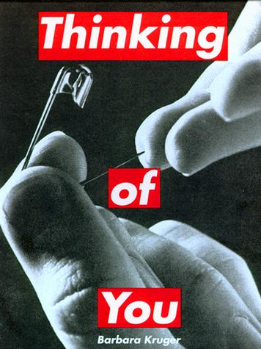 2. 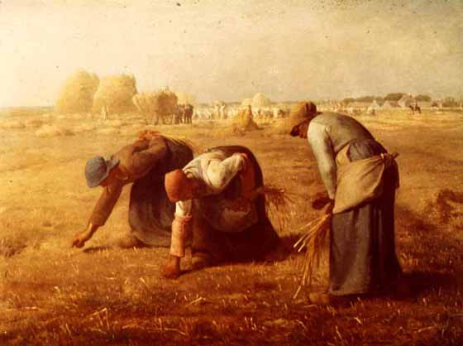3.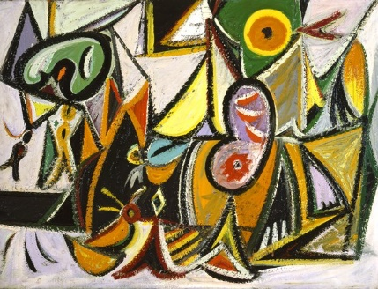 4. 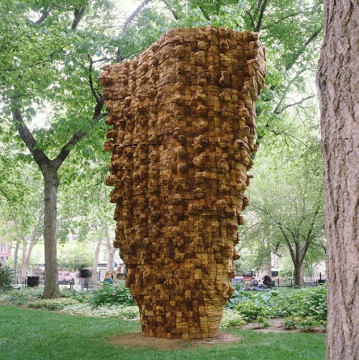5.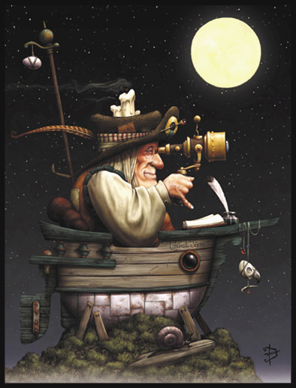6.

