Sept 24, 2019
Art Foundations
Journal Entry #10
- ART THINK: look at the art work below and answer the following questions:

ANNOUNCEMENTS/REMINDERS:
- Homework: Drawing in sketchbook: draw an “observational” drawing of some things you find in your pocket or back pack (draw for at least 30 min.)
- Journal check TODAY!
- Doodle portraits due TODAY! (Fill out late contract and turn in if you don’t finish today.)
OBJECTIVES:
- Finish doodle portraits and turn in with score sheet
- Finish Sketch book cover and check off
- Do your homework if you have time.

Look at this artwork and answer the following questions:
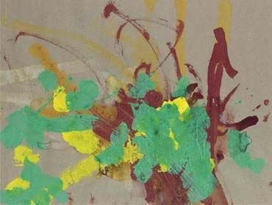
- Do you consider this to be art? Why or why not?
- What if I told you it sold for over $25,000.00, would that change your opinion? Why or why not?
- What if I told you Picasso owned an artwork by this artist, would that change your opinion? Why or why not?

