November 15, 2019
ART 1020 CE
Journal Entry #28
- ART THINK: Which of the following ink drawings below do you like the best and WHY?
ANNOUNCEMENTS/REMINDERS:
- Gesture Sketchbook check TODAY! (15)
OBJECTIVES:
- Gesture drawing
- Work on “Botanical Ink Drawing”

1.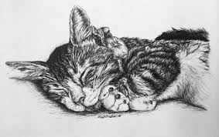
2.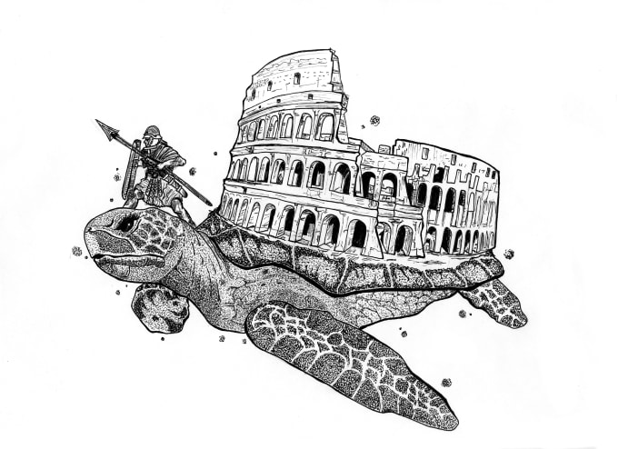
3. 