October 22, 2019
ART 1020 CE
Journal Entry #19
- ART THINK: See if you can identify the parts of shading on the sphere below:

ANNOUNCEMENTS/REMINDERS:
- Tonal drawing due TODAY!
- HOME WORK CHECK TODAY: draw 4 spheres with ink, using hatching, cross hatching, random scribbles and stippling to shade the spheres.
OBJECTIVES:
- Gesture drawing
- Watch clip (stippling)
- Turn in tonal drawing on gray paper
- Begin stipple drawing (fruit or vegetable) in play book.

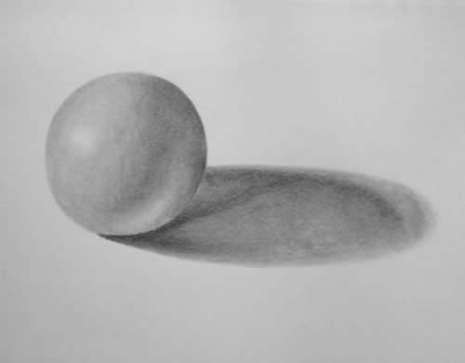
1.
4.
2.
3.

