Date: April 30, 2018
In your journal record the following:
ART 1010 ENTRY #33:
ART THINK: See if you can match the self portrait to the artist below:
Announcements/Reminders:
- Critique #2 is now past due – turn in ASAP if you haven’t already!
Today’s Objective:
- Finishing assignment #3
Homework: Finish up Assignment #3 if you don’t finish in class – we start presenting NEXT TIME!

See if you can match the artist to the self portrait:
1. Rembrandt 2. Vincent Van Gogh 3. Andy Warhol 4. Frieda Kahlo 5. Albrecht Durer 6. Pablo Picasso.
A.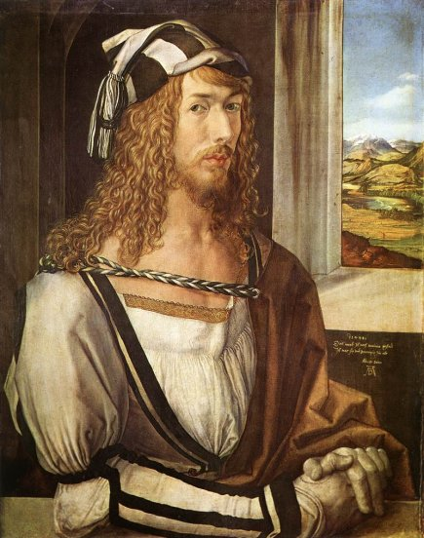B.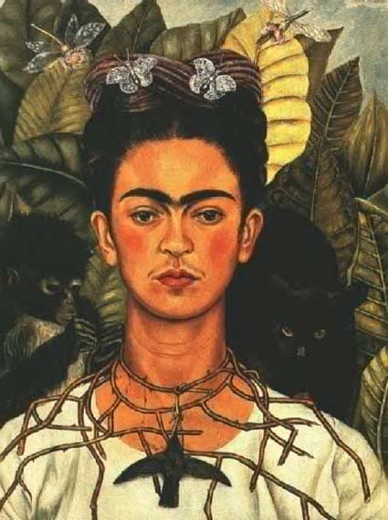C. 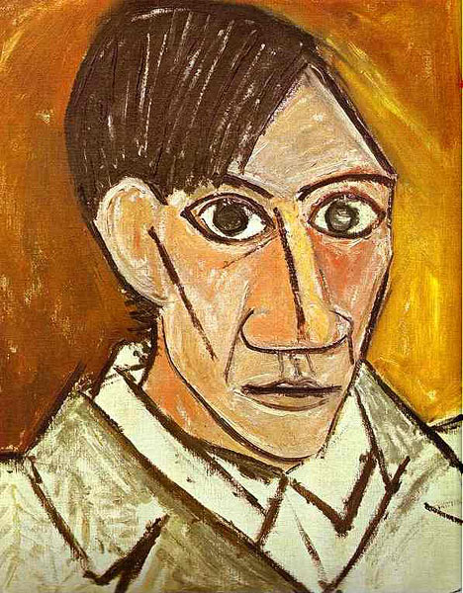

D.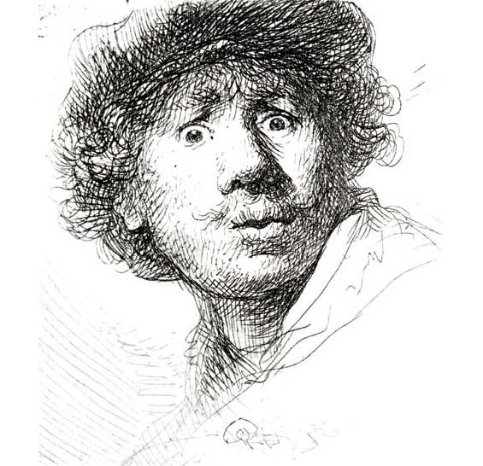E. 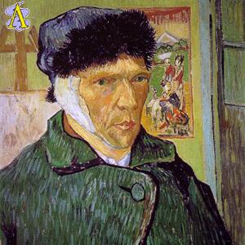F. 