Date: March 20, 2018
In your journal record the following:
ART 1010 ENTRY #21:
ART THINK: Look at the prints below, which is your favorite and WHY?
Announcements/Reminders:
- Concurrent Enrollment art contest entries are due APRIL 3rd (give out flyer)
Today’s Objective:
- Review steps to print making assignment
- Work on print
Homework: CHECK YOUR GRADE! Let me know TODAY if there is a mistake!

- 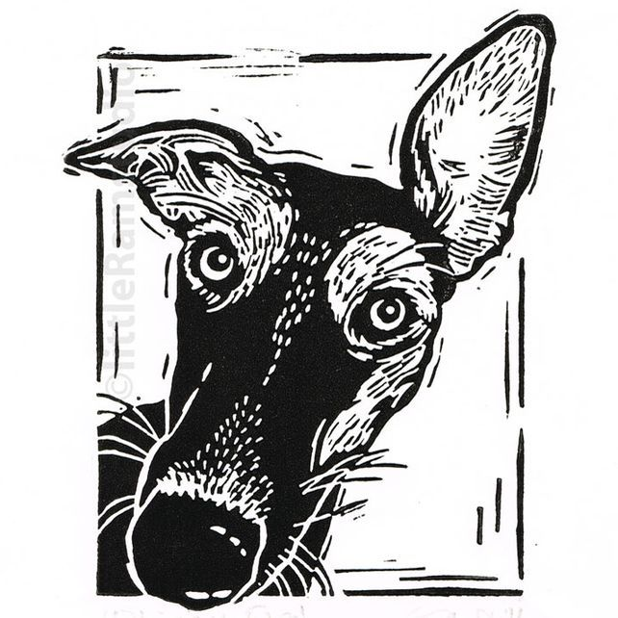2. 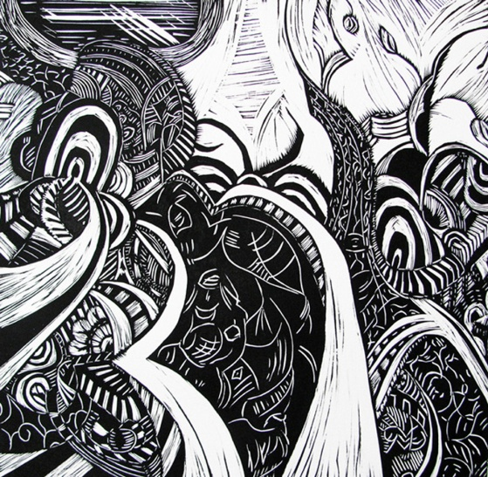
3. 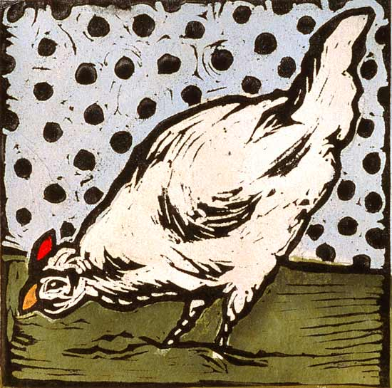 4. 