October 9, 2020
ART 1010 CE
Journal Entry #17
- ART THINK: Look at the artworks below and see if you can match them to the correct artist.
ANNOUNCEMENTS/REMINDERS:
- Critiques due NEXT TIME!
- Midterm is October 23rd
OBJECTIVES:
- CHAPTER 6
- Finishing dry point print

See how many artists you can match to their art works. Here are your choices: Michelangelo, DaVinci, Rembrandt, VanGogh, Picasso, Warhol, Dali, Vermeer.
1.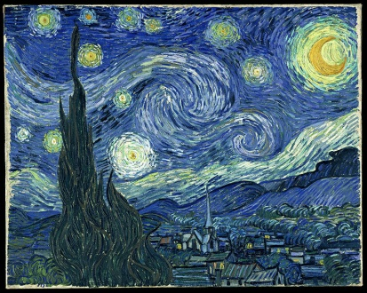 2. 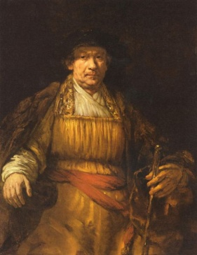 3. 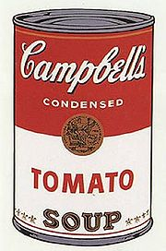
4.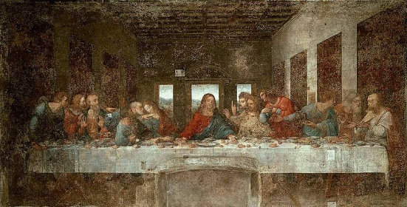 5. 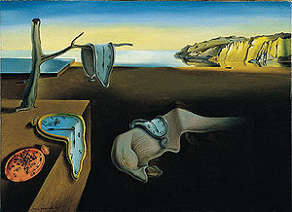
6. 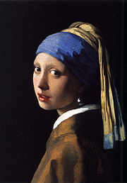 7.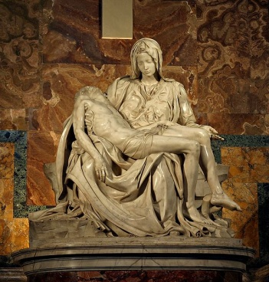 8. 