September 23, 2019

ART 1010 CE

Journal Entry #9

* ART THINK: **See if you answer any of the “art trivia” questions below:**

ANNOUNCEMENTS/REMINDERS:

* Assignment #1 (Japanese scroll) is due TODAY!

OBJECTIVES:

1. Go over Chapter 10
2. Finish scroll (assignment #3) & turn in

C:\Documents and Settings\staff\Local Settings\Temporary Internet Files\Content.IE5\QUMSZBS3\MCj04344110000[1].wmfART THINK

**Time for art history trivia! See how many of the following questions you can answer (or guess) correctly:**

1. What famous museum displays the Mona Lisa?
2. What famous painting by Edvard Munch was stolen a few years ago?
3. How many painting did Vincent Van Gogh sell during his life time?
4. What artist is remembered for painting Campbell Soup cans?
5. What art movement did Renoir, Monet and Degas belong to?
6. What country did Leonardo DaVinci come from?
7. What nationality was Van Gogh?
8. What does Leonardo DaVinci, Michelangelo, Donatello and Raphael all have in common.

ANSWERS:

1. The Louvre in Paris, France 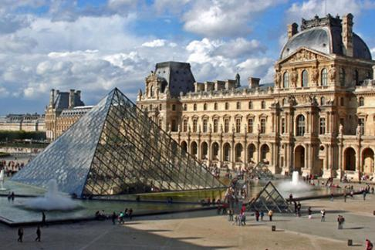
2. The Scream (or the Cry) 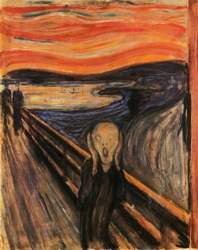
3. Just one☹ (most think it was this one) 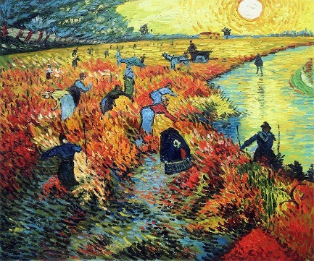
4. Andy Warhol 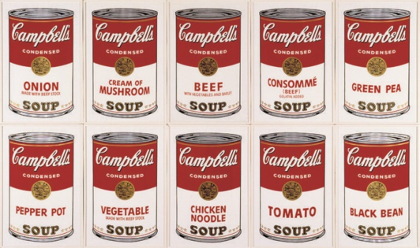
5. They all were Impressionist
6. Da Vinci was Italian
7. Van Gogh was Dutch
8. All Renaissance artists from Italy (and they are also Ninja Turtle’s names)