Date: December 6, 2017
In your journal record the following:
AP STUDIO ART ENTRY #33:
ART THINK : Look at the paintings below, tell me which one you connect with and WHY?
Announcements/Reminders:
- Concentration #2 is due TODAY!
- 31 Nights is due on Dec. 14th.
Today’s Objective:
- Turn in concentration #2
- Talk about next project: Altered Reality
- Begin planning for Altered Reality
Homework: Work on 31 Nights

1. 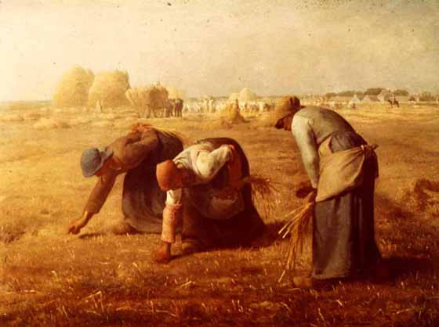 2. 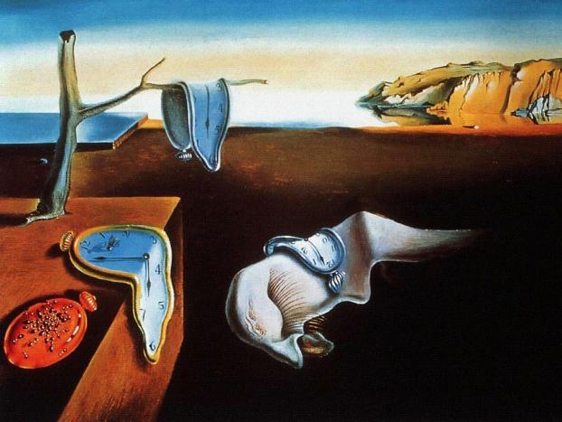3. 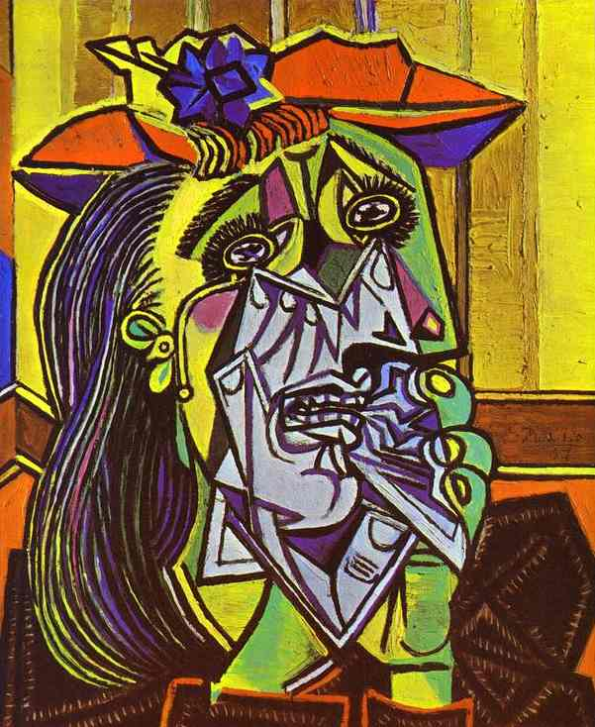4. 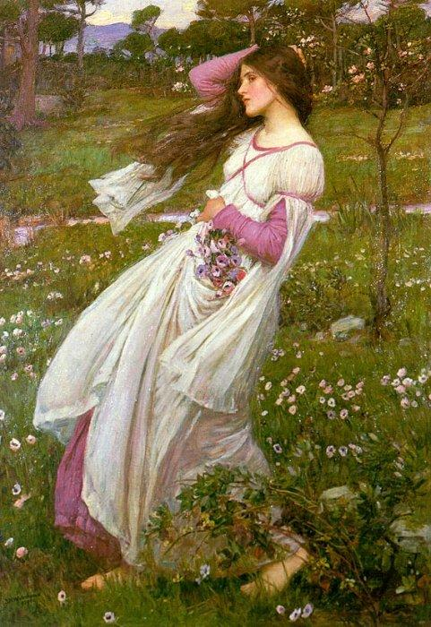 5. 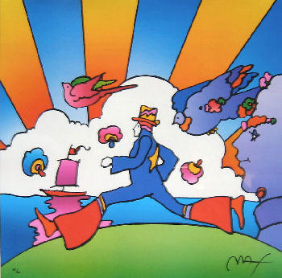
6. 