Date: November 15, 2017
In your journal record the following:
AP STUDIO ART ENTRY #27:
ART THINK : See if you can guess the material used for the art works below:
Announcements/Reminders:
- Journal check NEXT TIME!
- Non-traditional Medium Art work due on November 21st!
Today’s Objective:
- Review (look at task sheet
- Work on Non-traditional Material art work.
Homework: Work on 31 Nights

1. 2.
3. 4. 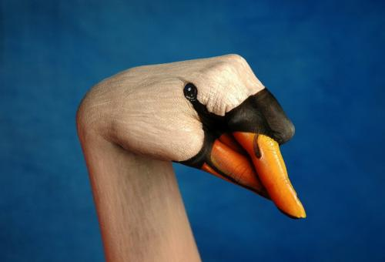
5.

