Date: October 18, 2017
In your journal record the following:
AP STUDIO ART ENTRY #18:
ART THINK : Watch clip on Denise Kraemer (print artist) and finish this sentence:
“While watching this clip I thought . . .”
Announcements/Reminders:
- October 24 is the last day to turn in late work or re-dos for this term.
- Seniors remember to sign up for Portfolio Day ASAP – it opens to Juniors on Oct 20th.
Today’s Objective:
- Talk about finishing techniques.
- Work on print project (finish carving design and print a proof).
Homework: Work on 31 Nights & check grades!

1.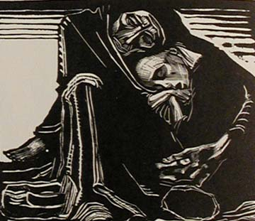 2. 3. 4. 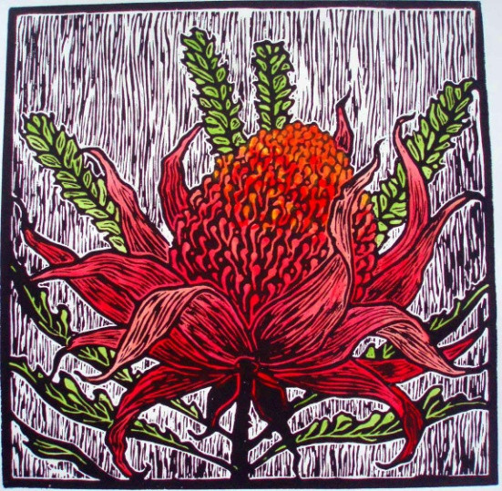 5.

